COMSATS UNIVERSITY ISLAMABAD
Department of Computer Science
Lab 2 Tasks Report
WEB TECHNOLOGIES
Muhammad Umar Saeed
Reg. No.: Not yet assigned — migration case in process

Lab 01: HTML5 Fundamentals and Document Structure

File: index.html
<!DOCTYPE html>
<html lang="en">
<head>
<!-- Lab 01: HTML5 Fundamentals and Document Structure -->
<!-- This is the head section - it contains metadata about the page -->
<meta charset="UTF-8">
<meta name="viewport" content="width=device-width, initial-scale=1.0">
<title>CUI Wah Campus - Student Portal</title>
</head>
<body>

<!-- Main Page Heading -->
<h1>Welcome to CUI Wah Campus Student Portal</h1>

<!-- Introductory Paragraph -->
<p>
This is the official student portal for COMSATS University Islamabad, Wah Campus.
Here you can find information about programs, facilities, announcements, and student services.
This portal is designed to help students navigate campus life easily.
</p>

<h2>Quick Links</h2>
<p>
Use the navigation links below to explore different sections of the portal.
More pages will be added as we progress through the labs.
</p>

<h2>About This Portal</h2>
<p>
This portal was created as part of the Web Development lab course.
It demonstrates the basic structure of an HTML5 document including
the DOCTYPE declaration, html element, head section, and body section.
</p>

<!-- Footer Information -->
<h3>Contact</h3>
<p>
COMSATS University Islamabad, Wah Campus<br>
Email: info@comsats.edu.pk<br>
Phone: +92-51-8157218
</p>

</body>
</html>

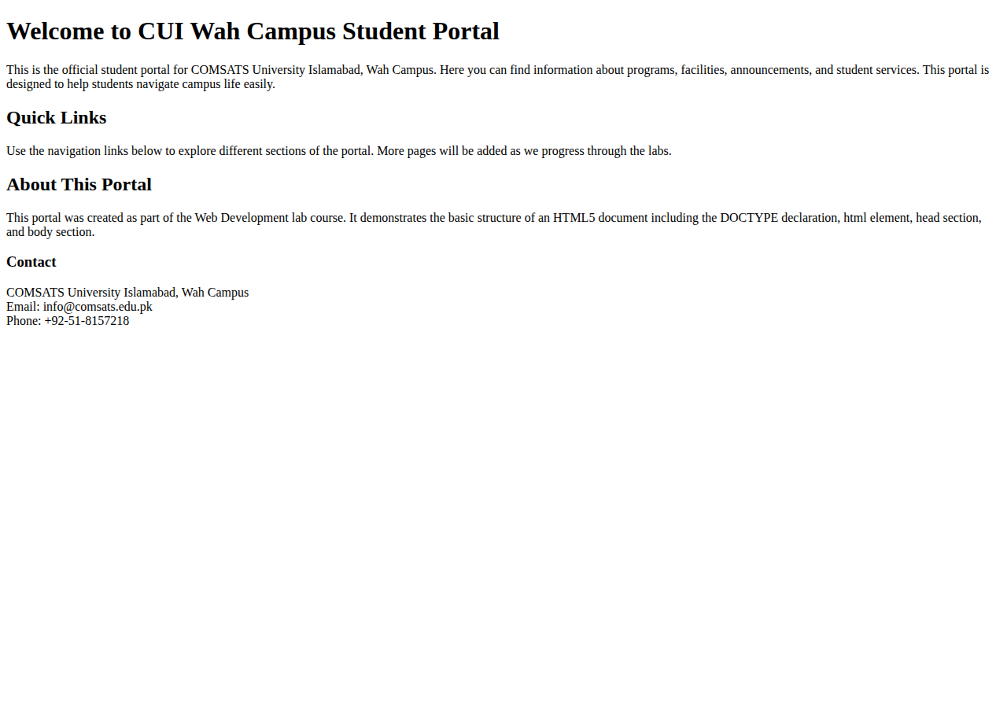
Output: index.html (Lab 01)

Lab 02: Elements, Tags, Attributes, Nesting and Validation

File: index.html
<!DOCTYPE html>
<html lang="en">
<head>
<!-- Lab 02: Elements, Tags, Attributes, Nesting and Validation -->
<meta charset="UTF-8">
<meta name="viewport" content="width=device-width, initial-scale=1.0">
<title>Student Profile - Muhammad Umar Saeed</title>
</head>
<body>

<h1>Student Profile</h1>

<!-- Section with unique id -->
<section id="personal-info">
<h2>Personal Information</h2>
<p>My name is <strong>Ahmed Raza</strong> and I am a student at CUI Wah Campus.</p>
<p title="This is my student ID number">Roll Number: SP23-BCS-041</p>
<p>I am currently in my 5th semester studying Bachelor of Science in Computer Science.</p>
</section>

<!-- Section with unique id -->
<section id="academic-info">
<h2>Academic Information</h2>
<p>I am enrolled in the <em>BS Computer Science</em> program.</p>
<p>My current GPA is <mark>2.51</mark> out of 4.0.</p>
<p>I am particularly interested in <span class="highlight">Full-stack Development</span> and <span class="highlight">Database Systems</span>.</p>
<p>I also enjoy <span class="highlight">Programming</span> in Python and Java.</p>
</section>

<!-- Using the same class on multiple elements -->
<h2>Skills</h2>
<ul>
<li><span class="skill-tag">HTML</span> - Beginner level</li>
<li><span class="skill-tag">CSS</span> - Beginner level</li>
<li><span class="skill-tag">Python</span> - Intermediate level</li>
</ul>

<h2>Hobbies</h2>
<p title="I love reading tech blogs and books">Reading</p>
<p title="I play cricket on weekends">Cricket</p>
<p title="I enjoy solving coding challenges">Programming</p>

</body>
</html>

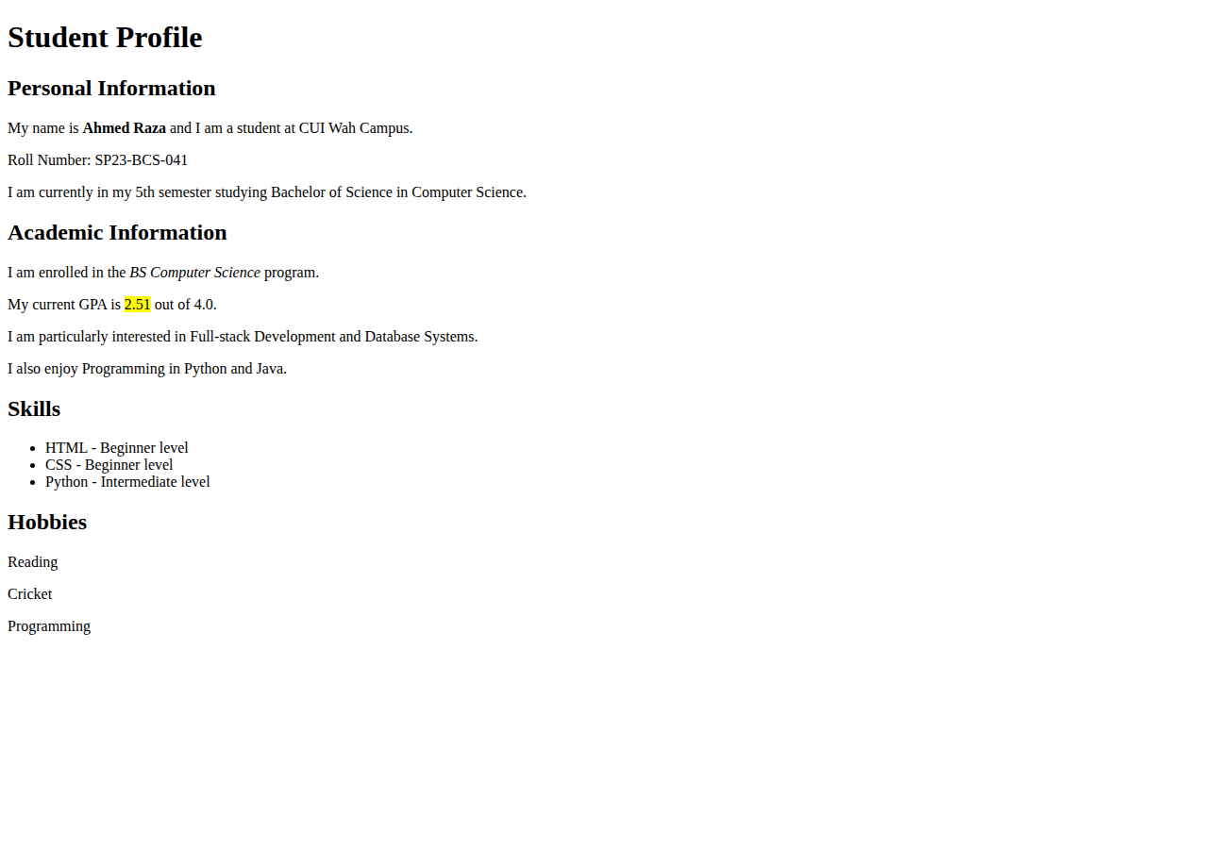
Output: index.html (Lab 02)

Lab 03: Headings, Paragraphs, Text Formatting and Hyperlinks

File: index.html
<!DOCTYPE html>
<html lang="en">
<head>
<!-- Lab 03: Headings, Paragraphs, Text Formatting and Hyperlinks -->
<meta charset="UTF-8">
<meta name="viewport" content="width=device-width, initial-scale=1.0">
<title>Department of Computer Science - CUI Wah</title>
</head>
<body>

<!-- Navigation Area -->
<nav>
<h2>Navigation</h2>
<ul>
<li><a href="index.html">Home</a></li>
<li><a href="programs.html">Programs</a></li>
<li><a href="contact.html">Contact</a></li>
<li><a href="https://www.comsats.edu.pk" target="_blank" rel="noopener noreferrer">COMSATS Official Website</a></li>
</ul>
</nav>

<hr>

<h1>Department of Computer Science</h1>

<p>
The Department of Computer Science at COMSATS University Islamabad, Wah Campus
offers comprehensive programs in computer science and related fields.
</p>

<h2>About the Department</h2>
<p>
The department was established to provide quality education in computer science
and produce skilled professionals for the industry. We have <strong>highly qualified faculty</strong>
and <em>state-of-the-art laboratories</em>.
</p>

<h2>Programs Offered</h2>

<h3>BS Computer Science</h3>
<p>
The <mark>BS Computer Science</mark> program is a 4-year undergraduate degree
that covers fundamentals of computing, programming, algorithms, data structures,
databases, and software engineering.
</p>

<h3>BS Software Engineering</h3>
<p>
The <small>BS Software Engineering</small> program focuses on the design and development
of large-scale software systems. Students learn about software development
lifecycle, testing, and project management.
</p>

<h2>Why Choose Us?</h2>
<p>
Our department provides:
</p>
<p>
Industry-relevant curriculum<br>
Experienced faculty members<br>
Modern computer labs<br>
Internship opportunities<br>
Research exposure
</p>

<hr>

<h2>Useful Links</h2>
<p>
Visit the <a href="https://www.comsats.edu.pk" target="_blank" rel="noopener noreferrer">official COMSATS website</a> for more information.
</p>
<p>
Check out the <a href="programs.html">programs page</a> for detailed course information.
</p>
<p>
For any queries, visit our <a href="contact.html">contact page</a>.
</p>

<hr>

<p><small>&copy; 2026 Department of Computer Science, CUI Wah Campus</small></p>

</body>
</html>

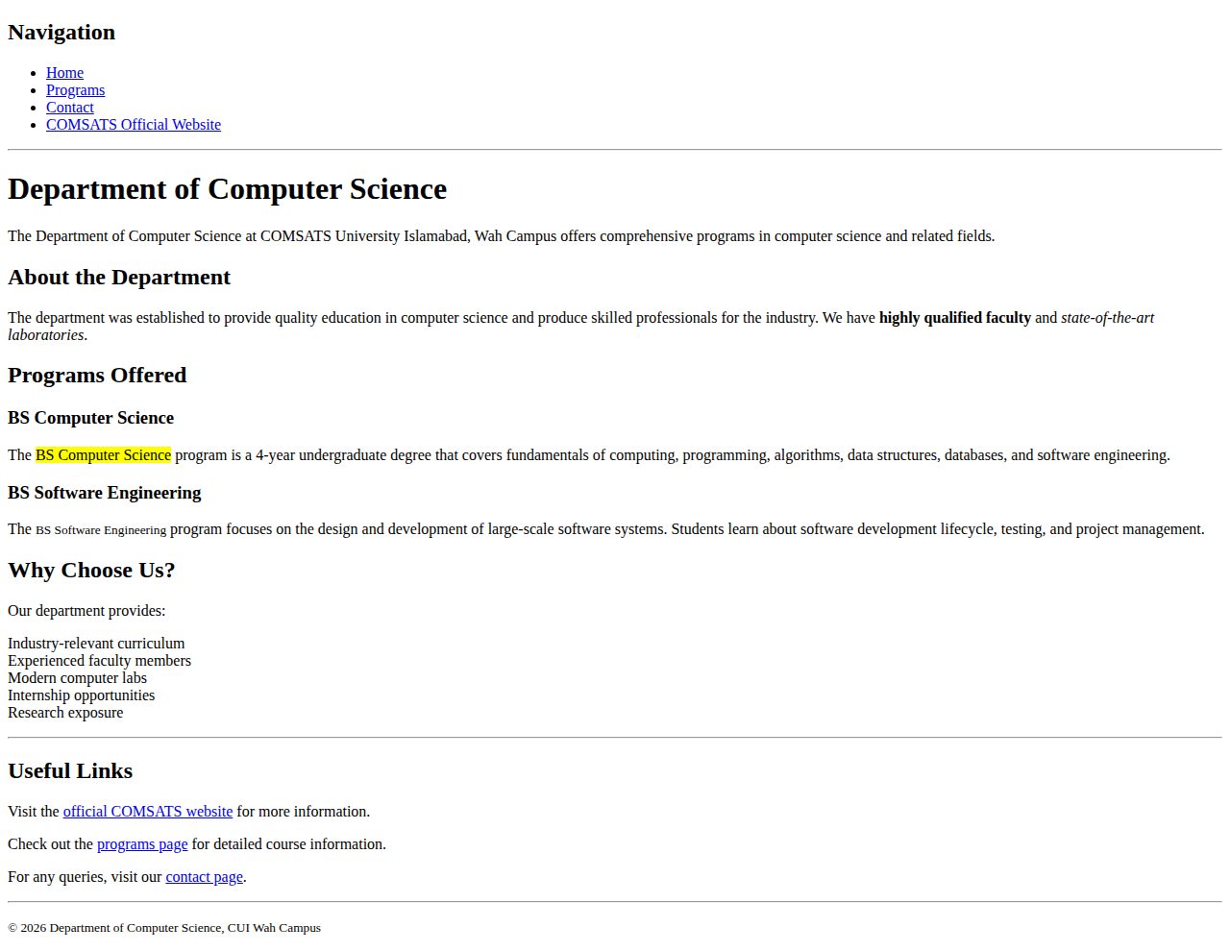
Output: index.html (Lab 03)

File: programs.html
<!DOCTYPE html>
<html lang="en">
<head>
<meta charset="UTF-8">
<meta name="viewport" content="width=device-width, initial-scale=1.0">
<title>Programs - CUI Wah</title>
</head>
<body>

<nav>
<h2>Navigation</h2>
<ul>
<li><a href="index.html">Home</a></li>
<li><a href="programs.html">Programs</a></li>
<li><a href="contact.html">Contact</a></li>
</ul>
</nav>

<hr>

<h1>Academic Programs</h1>

<h2>Undergraduate Programs</h2>

<h3>BS Computer Science</h3>
<p>
Duration: 4 years (8 semesters)<br>
Total Credit Hours: 130<br>
Eligibility: Intermediate with Mathematics
</p>

<h3>BS Software Engineering</h3>
<p>
Duration: 4 years (8 semesters)<br>
Total Credit Hours: 136<br>
Eligibility: Intermediate with Mathematics
</p>

<h3>BS Information Technology</h3>
<p>
Duration: 4 years (8 semesters)<br>
Total Credit Hours: 130<br>
Eligibility: Intermediate with Mathematics
</p>

<h2>Graduate Programs</h2>

<h3>MS Computer Science</h3>
<p>
Duration: 2 years (4 semesters)<br>
Total Credit Hours: 30<br>
Eligibility: BS in CS or related field
</p>

<p><a href="index.html">&larr; Back to Home</a></p>

<hr>
<p><small>&copy; 2026 CUI Wah Campus</small></p>

</body>
</html>

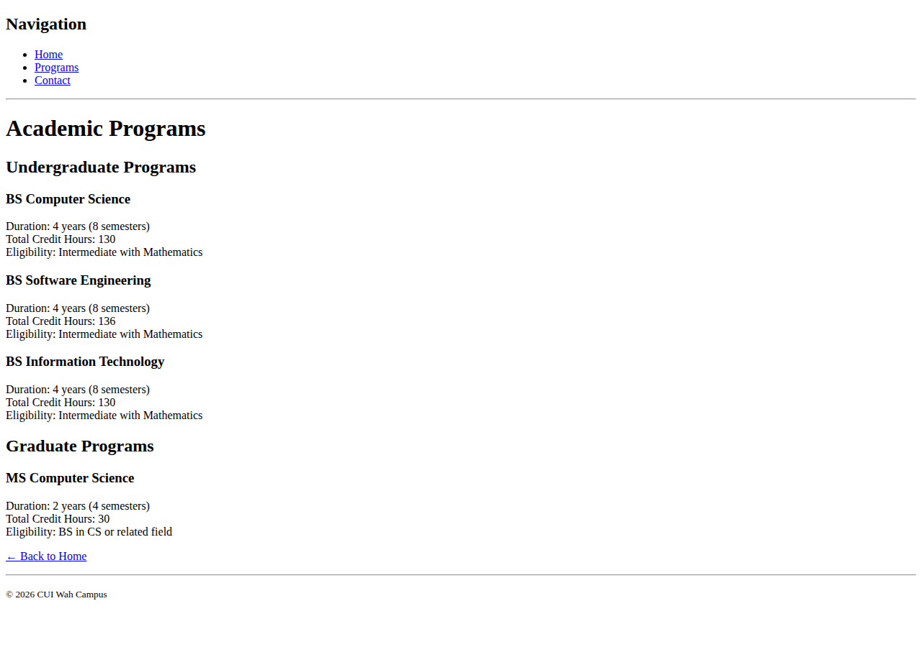
Output: programs.html (Lab 03)

File: contact.html
<!DOCTYPE html>
<html lang="en">
<head>
<meta charset="UTF-8">
<meta name="viewport" content="width=device-width, initial-scale=1.0">
<title>Contact - CUI Wah</title>
</head>
<body>

<nav>
<h2>Navigation</h2>
<ul>
<li><a href="index.html">Home</a></li>
<li><a href="programs.html">Programs</a></li>
<li><a href="contact.html">Contact</a></li>
</ul>
</nav>

<hr>

<h1>Contact Us</h1>

<h2>Address</h2>
<p>
COMSATS University Islamabad<br>
Park Road, Chak Shahzad<br>
Islamabad 45550, Pakistan
</p>

<h2>Phone</h2>
<p>+92-51-8157218</p>

<h2>Email</h2>
<p>info@comsats.edu.pk</p>

<h2>Office Hours</h2>
<p>Monday to Friday: 8:00 AM - 5:00 PM</p>
<p>Saturday: 9:00 AM - 1:00 PM</p>

<p><a href="index.html">&larr; Back to Home</a></p>

<hr>
<p><small>&copy; 2026 CUI Wah Campus</small></p>

</body>
</html>

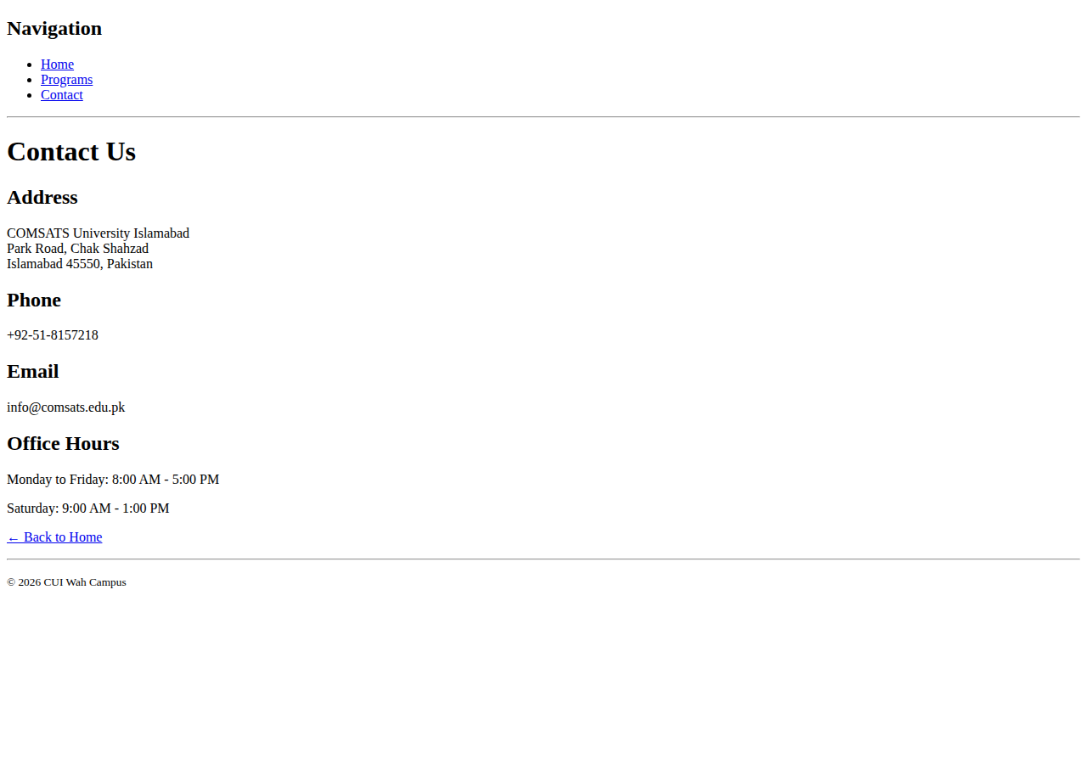
Output: contact.html (Lab 03)

Lab 04: Images, Audio and Video

File: index.html
<!DOCTYPE html>
<html lang="en">
<head>
<!-- Lab 04: Images, Audio and Video -->
<meta charset="UTF-8">
<meta name="viewport" content="width=device-width, initial-scale=1.0">
<title>CUI Wah Campus - Media Page</title>
</head>
<body>

<h1>CUI Wah Campus Media Page</h1>

<p>This page demonstrates embedding images, audio, and video using HTML5.</p>

<hr>

<!-- Image Section -->
<h2>Campus Images</h2>

<figure>
<img src="https://encrypted-tbn0.gstatic.com/images?q=tbn:ANd9GcSY4Uhh_W-HSlEYonHrjtQuEkYqQd25b3f-4K10zPc12z37_GMAN-G4Rftp&s=10"
alt="Main academic building of COMSATS University Wah Campus with modern architecture"
width="400" height="250">
<figcaption>The main academic building at CUI Wah Campus</figcaption>
</figure>

<figure>
<img src="https://cuiwah.edu.pk/assets/img/faculties.jpg"
alt="Students working in the computer laboratory with latest equipment"
width="400" height="250">
<figcaption>Computer laboratory with modern equipment</figcaption>
</figure>

<hr>

<!-- Audio Section -->
<h2>Campus Audio</h2>

<p>Listen to some random nonsense that wouldn't even run because it's referencing a non existing file:</p>

<figure>
<audio controls>
<source src="campus-anthem.mp3" type="audio/mpeg">
<source src="campus-anthem.ogg" type="audio/ogg">
Your browser does not support the audio element. Please update your browser to listen to the audio.
</audio>
<figcaption>Yeah, my mooscles is geeting stroonger, My mooscles, it's geeting beegar, yeahhhhhh</figcaption>
</figure>

<hr>

<!-- Video Section -->
<h2>Campus Video Tour</h2>

<p>Take a virtual tour of our campus:</p>

<figure>
<video controls width="640" height="360">
<source src="https://www.youtube.com/watch?v=8FrSwfGEFkI" >
<source src="https://www.youtube.com/watch?v=8FrSwfGEFkI" >
Your browser does not support the video element. Please update your browser to watch the video.
</video>
<figcaption>Virtual tour of CUI Wah Campus</figcaption>
</figure>

<hr>

<h2>Media Attributes Tested</h2>
<ul>
<li><strong>controls</strong> - Shows play/pause/volume controls</li>
<li><strong>width/height</strong> - Sets video dimensions</li>
<li><strong>alt text</strong> - Describes images for screen readers</li>
<li><strong>figure/figcaption</strong> - Provides captions for media</li>
<li><strong>source</strong> - Allows multiple format fallbacks</li>
</ul>

<hr>
<p><small>&copy; 2026 CUI Wah Campus</small></p>

</body>
</html>

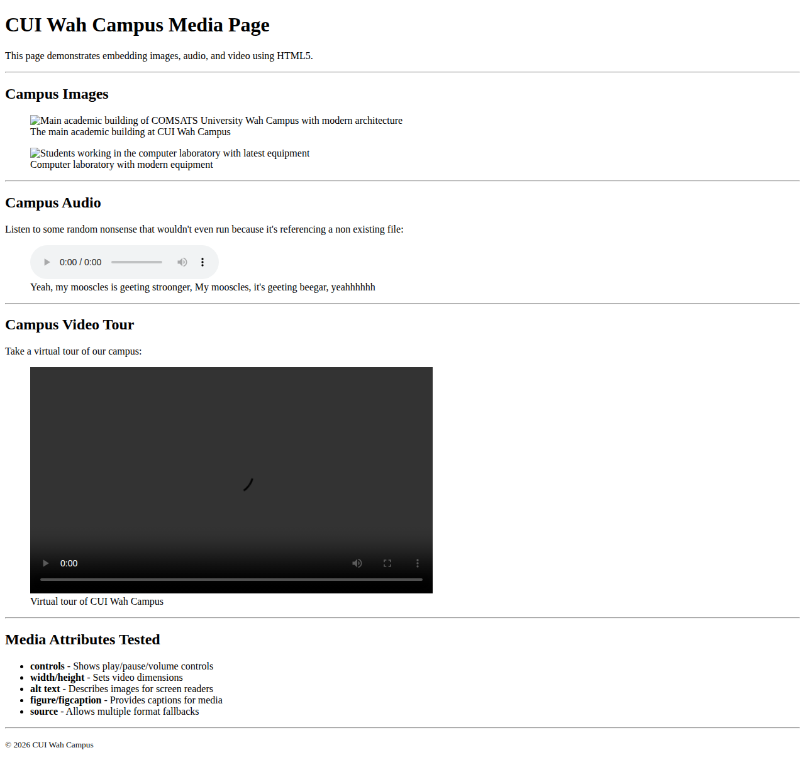
Output: index.html (Lab 04)

Lab 05: Lists and Tables

File: index.html
<!DOCTYPE html>
<html lang="en">
<head>
<!-- Lab 05: Lists and Tables -->
<meta charset="UTF-8">
<meta name="viewport" content="width=device-width, initial-scale=1.0">
<title>BS Computer Science - Program Information</title>
</head>
<body>

<h1>BS Computer Science Program Information</h1>

<hr>

<!-- Unordered List - Facilities -->
<h2> Campus Facilities</h2>
<ul>
<li>Modern Computer Laboratories</li>
<li>High-Speed Internet Access</li>
<li>University Library</li>
<li>Cafeteria and Food Court</li>
<li>Sports Complex</li>
<li>Wi-Fi Enabled Campus</li>
</ul>

<hr>

<!-- Ordered List - Application Steps -->
<h2>How to Apply</h2>
<ol>
<li>Visit the COMSATS admissions portal online</li>
<li>Create an account with your personal details</li>
<li>Fill out the application form completely</li>
<li>Upload required documents (CNIC, transcripts, photos)</li>
<li>Pay the application fee via bank challan</li>
<li>Submit the application before the deadline</li>
<li>Wait for the merit list to be announced</li>
<li>Complete fee submission if selected</li>
</ol>

<hr>

<!-- Description List - Web Development Terms -->
<h2>Web Development Terms</h2>
<dl>
<dt>HTML (HyperText Markup Language)</dt>
<dd>The standard markup language for creating web pages and web applications.</dd>

<dt>CSS (Cascading Style Sheets)</dt>
<dd>A style sheet language used for describing the presentation of a document written in HTML.</dd>

<dt>JavaScript</dt>
<dd>A programming language that enables interactive web pages and is an essential part of web applications.</dd>

<dt>DOM (Document Object Model)</dt>
<dd>A programming interface for HTML documents that represents the page as a tree of objects.</dd>

<dt>API (Application Programming Interface)</dt>
<dd>A set of rules and protocols that allows different software applications to communicate with each other.</dd>
</dl>

<hr>

<!-- Table - Courses -->
<h2>Course Catalog (Fall 2026)</h2>

<table border="1">
<caption>BS Computer Science - Semester 5 Courses</caption>
<thead>
<tr>
<th scope="col">Course Code</th>
<th scope="col">Course Title</th>
<th scope="col">Credit Hours</th>
<th scope="col">Semester</th>
</tr>
</thead>
<tbody>
<tr>
<td>CS-301</td>
<td>Data Structures and Algorithms</td>
<td>3</td>
<td>5th</td>
</tr>
<tr>
<td>CS-302</td>
<td>Database Systems</td>
<td>3</td>
<td>5th</td>
</tr>
<tr>
<td>CS-303</td>
<td>Operating Systems</td>
<td>3</td>
<td>5th</td>
</tr>
<tr>
<td>CS-304</td>
<td>Web Development</td>
<td>3</td>
<td>5th</td>
</tr>
<tr>
<td>CS-305</td>
<td>Object Oriented Programming</td>
<td>3</td>
<td>5th</td>
</tr>
<tr>
<td>CS-306</td>
<td>Discrete Mathematics</td>
<td>3</td>
<td>5th</td>
</tr>
</tbody>
</table>

<hr>

<!-- Second Table - Lab Schedule -->
<h2>Lab Schedule</h2>

<table border="1">
<caption>Weekly Lab Schedule - CS Department</caption>
<thead>
<tr>
<th scope="col">Day</th>
<th scope="col">Time</th>
<th scope="col">Lab</th>
<th scope="col">Instructor</th>
</tr>
</thead>
<tbody>
<tr>
<td rowspan="2">Monday</td>
<td>9:00 - 11:00</td>
<td>Programming Lab</td>
<td>Dr. Ahmed</td>
</tr>
<tr>
<td>2:00 - 4:00</td>
<td>Database Lab</td>
<td>Dr. Fatima</td>
</tr>
<tr>
<td rowspan="2">Wednesday</td>
<td>9:00 - 11:00</td>
<td>Web Dev Lab</td>
<td>Dr. Ali</td>
</tr>
<tr>
<td>2:00 - 4:00</td>
<td>OS Lab</td>
<td>Dr. Sara</td>
</tr>
<tr>
<td>Friday</td>
<td>9:00 - 12:00</td>
<td>Project Lab</td>
<td>Dr. Usman</td>
</tr>
</tbody>
</table>

<hr>
<p><small>&copy; 2026 Department of Computer Science, CUI Wah Campus</small></p>

</body>
</html>

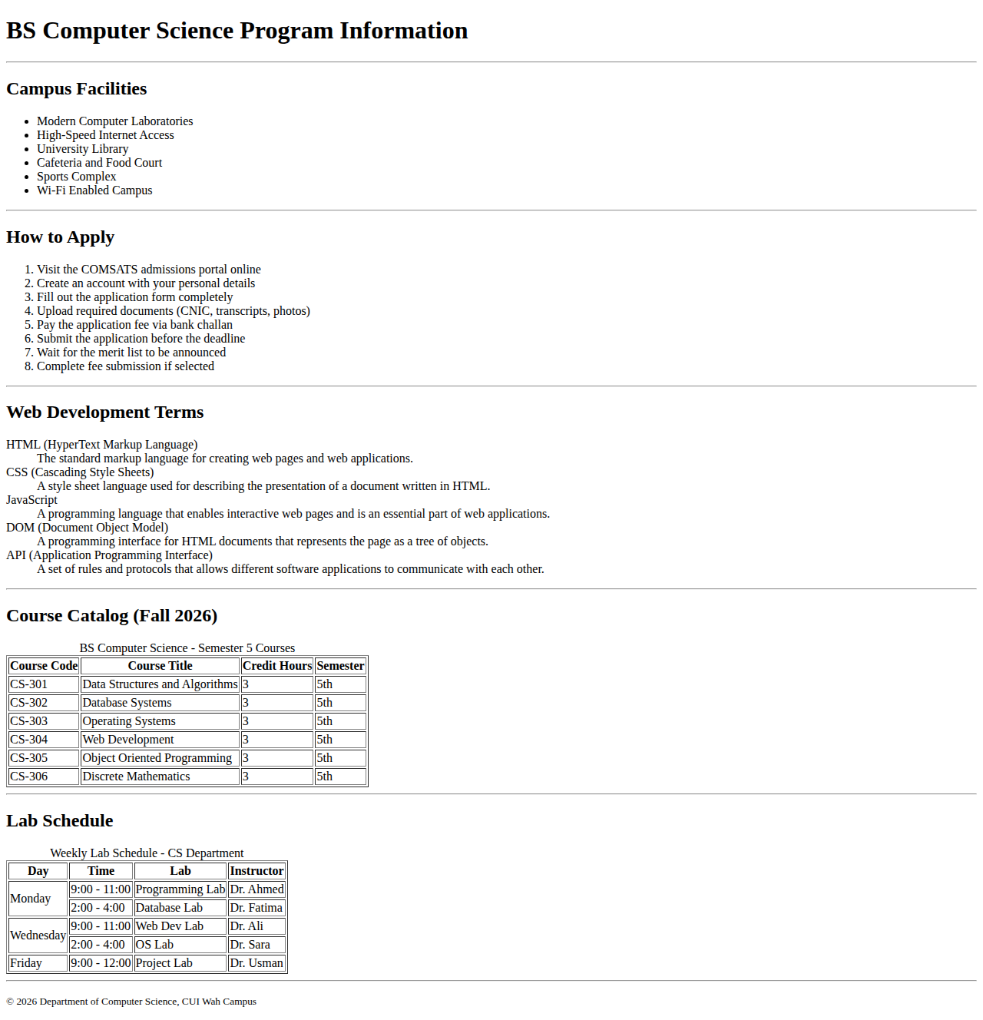
Output: index.html (Lab 05)

Lab 06: HTML5 Elements, Attributes and Browser Support

File: index.html
<!DOCTYPE html>
<html lang="en">
<head>
<!-- Lab 06: HTML5 Elements, Attributes and Browser Support -->
<meta charset="UTF-8">
<meta name="viewport" content="width=device-width, initial-scale=1.0">
<title>HTML5 Features Demo - CUI Wah</title>
</head>
<body>

<h1>HTML5 Features Demonstration</h1>

<p>This page demonstrates various HTML5 features and their browser support.</p>

<hr>

<!-- Feature 1: Details/Summary -->
<h2>1. Details and Summary</h2>
<details>
<summary>Click to expand - What is HTML5?</summary>
<p>HTML5 is the fifth and current major version of HTML. It provides new elements, attributes, and APIs for building modern web applications.</p>
</details>

<details>
<summary>Click to expand - What are the new features in HTML5?</summary>
<p>HTML5 introduced semantic elements like header, nav, main, section, article, footer. It also added audio, video, canvas, and form improvements.</p>
</details>

<hr>

<!-- Feature 2: Progress -->
<h2>2. Progress Bar</h2>
<p>Course Completion Progress:</p>
<progress value="70" max="100">70%</progress>
<p>70% of the course has been completed.</p>

<hr>

<!-- Feature 3: Meter -->
<h2>3. Meter Element</h2>
<p>Student GPA:</p>
<meter value="3.5" min="0" max="4.0" low="2.0" high="3.5" optimum="4.0">3.5</meter>
<p>GPA: 3.5 out of 4.0</p>

<hr>

<!-- Feature 4: Time -->
<h2>4. Time Element</h2>
<p>Lab Session: <time datetime="2026-09-22">September 22, 2026</time></p>
<p>Class Time: <time datetime="09:00">9:00 AM</time></p>
<p>Submission Deadline: <time datetime="2026-09-30T23:59:00">September 30, 2026 at 11:59 PM</time></p>

<hr>

<!-- Feature 5: Figure/Figcaption -->
<h2>5. Figure and Figcaption</h2>
<figure>
<img src="https://via.placeholder.com/300x200/1a2332/ffffff?text=CUI+Campus"
alt="CUI Wah Campus main building" width="300" height="200">
<figcaption>Figure 1: Main building of COMSATS University Wah Campus</figcaption>
</figure>

<hr>

<!-- Feature 6: Dialog -->
<h2>6. Dialog Element</h2>
<p>Click the button to open a dialog box:</p>
<dialog id="myDialog">
<p>This is a native HTML5 dialog element!</p>
<p>It can be used for modals and popups.</p>
<button onclick="document.getElementById('myDialog').close()">Close</button>
</dialog>
<button onclick="document.getElementById('myDialog').showModal()">Open Dialog</button>

<hr>

<!-- Feature 7: Mark -->
<h2>7. Mark Element (Highlight)</h2>
<p>This is some <mark>highlighted text</mark> using the HTML5 mark element.</p>

<hr>

<!-- Feature 8: Output -->
<h2>8. Output Element</h2>
<form oninput="result.value = parseInt(a.value) + parseInt(b.value)">
<input type="number" id="a" value="0" style="width:60px;"> +
<input type="number" id="b" value="0" style="width:60px;"> =
<output name="result" for="a b">0</output>
</form>

<hr>

<h2>Browser Support Notes</h2>
<ul>
<li><strong>details/summary</strong> - Supported in all modern browsers</li>
<li><strong>progress</strong> - Supported in all modern browsers</li>
<li><strong>meter</strong> - Supported in all modern browsers (except IE)</li>
<li><strong>time</strong> - Supported in all modern browsers</li>
<li><strong>dialog</strong> - Supported in Chrome, Edge, Firefox (not Safari until 2022)</li>
</ul>

<hr>
<p><small>&copy; 2026 CUI Wah Campus</small></p>

</body>
</html>

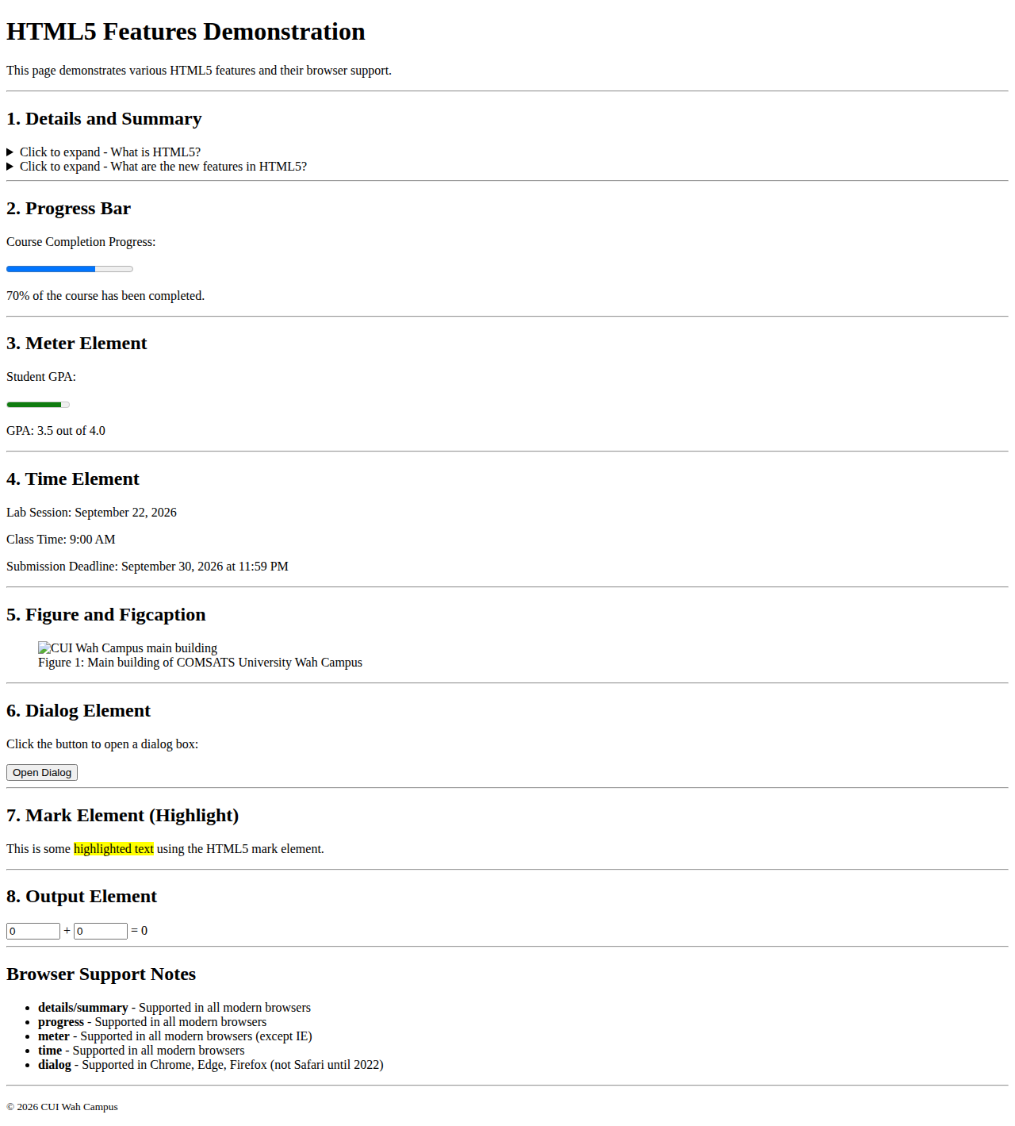
Output: index.html (Lab 06)

Lab 07: Block-Level vs Inline Elements, div and span

File: index.html
<!DOCTYPE html>
<html lang="en">
<head>
<!-- Lab 07: Block-Level vs Inline Elements, div and span -->
<meta charset="UTF-8">
<meta name="viewport" content="width=device-width, initial-scale=1.0">
<title>Student Dashboard - Block vs Inline</title>
<style>
/* Simple CSS to visualize block vs inline */
.block-demo { background: #e2e8f0; border: 2px solid #94a3b8; padding: 10px; margin: 8px 0; }
.inline-demo { background: #dbeafe; border: 2px solid #60a5fa; padding: 4px 8px; margin: 4px; }
.section-box { border: 1px solid #ccc; padding: 16px; margin: 16px 0; background: #fafafa; }
.status { font-size: 12px; padding: 2px 6px; border-radius: 3px; }
.active { background: #dcfce7; color: #166534; }
.pending { background: #fef3c7; color: #92400e; }
.course-type { font-size: 11px; background: #ede9fe; color: #5b21b6; padding: 2px 6px; border-radius: 3px; }
</style>
</head>
<body>

<h1>Student Dashboard</h1>
<p>This page demonstrates block-level vs inline elements, and the use of div and span.</p>

<hr>

<!-- BLOCK-LEVEL ELEMENTS -->
<h2>Block-Level Elements</h2>
<p>Block-level elements take up the full width and start on a new line:</p>

<div class="block-demo">
This is a div element. It is block-level, so it takes full width.
</div>
<div class="block-demo">
This is another div. It starts on a new line below the first one.
</div>

<hr>

<!-- STUDENT PROFILE - using div for grouping -->
<h2>Student Profile (Using div for grouping)</h2>

<div class="section-box">
<h3>Personal Details</h3>
<p><strong>Name:</strong> Ahmed Raza</p>
<p><strong>Roll Number:</strong> SP23-BCS-041</p>
<p><strong>Program:</strong> BS Computer Science</p>
<p><strong>Status:</strong> <span class="status active">Active</span></p>
</div>

<div class="section-box">
<h3>Current Courses</h3>
<p>
<span class="course-type">Core</span> Data Structures and Algorithms
<span class="status active">Enrolled</span>
</p>
<p>
<span class="course-type">Core</span> Database Systems
<span class="status active">Enrolled</span>
</p>
<p>
<span class="course-type">Elective</span> Web Development
<span class="status active">Enrolled</span>
</p>
<p>
<span class="course-type">Core</span> Operating Systems
<span class="status pending">Pending</span>
</p>
</div>

<div class="section-box">
<h3>Announcements</h3>
<p><strong>Midterm Exam:</strong> Scheduled for October 15-20, 2026</p>
<p><strong>Holiday:</strong> October 23-24 (Eid Milad-un-Nabi)</p>
<p><strong>Assignment:</strong> Web Development Lab 3 due September 30</p>
</div>

<hr>

<!-- INLINE ELEMENTS -->
<h2>Inline Elements</h2>
<p>Inline elements only take up as much width as needed and do not start on a new line:</p>

<div class="block-demo">
<p>This is a paragraph containing <span class="inline-demo">inline span 1</span>,
<span class="inline-demo">inline span 2</span>, and <span class="inline-demo">inline span 3</span>.
Notice how they all stay on the same line because span is an inline element.</p>
</div>

<p>More inline examples: <strong>Bold text</strong>, <em>Italic text</em>,
<mark>Highlighted text</mark>, and <small>Small text</small> are all inline elements.</p>

<hr>

<!-- Quick Links - using div for layout -->
<h2>Quick Links</h2>

<div class="section-box">
<h3>Academic</h3>
<p><a href="#">View Grades</a></p>
<p><a href="#">Course Registration</a></p>
<p><a href="#">Academic Calendar</a></p>
</div>

<div class="section-box">
<h3>Services</h3>
<p><a href="#">Library Portal</a></p>
<p><a href="#">IT Help Desk</a></p>
<p><a href="#">Student Email</a></p>
</div>

<hr>

<h2>Block vs Inline Summary</h2>
<table border="1">
<thead>
<tr>
<th>Block-Level Elements</th>
<th>Inline Elements</th>
</tr>
</thead>
<tbody>
<tr>
<td>div, h1-h6, p, ul, ol, li, table, form</td>
<td>span, strong, em, a, mark, small, img</td>
</tr>
<tr>
<td>Take full width, start on new line</td>
<td>Take only needed width, stay on same line</td>
</tr>
<tr>
<td>Can contain inline elements</td>
<td>Cannot contain block-level elements</td>
</tr>
</tbody>
</table>

<hr>
<p><small>&copy; 2026 CUI Wah Campus</small></p>

</body>
</html>

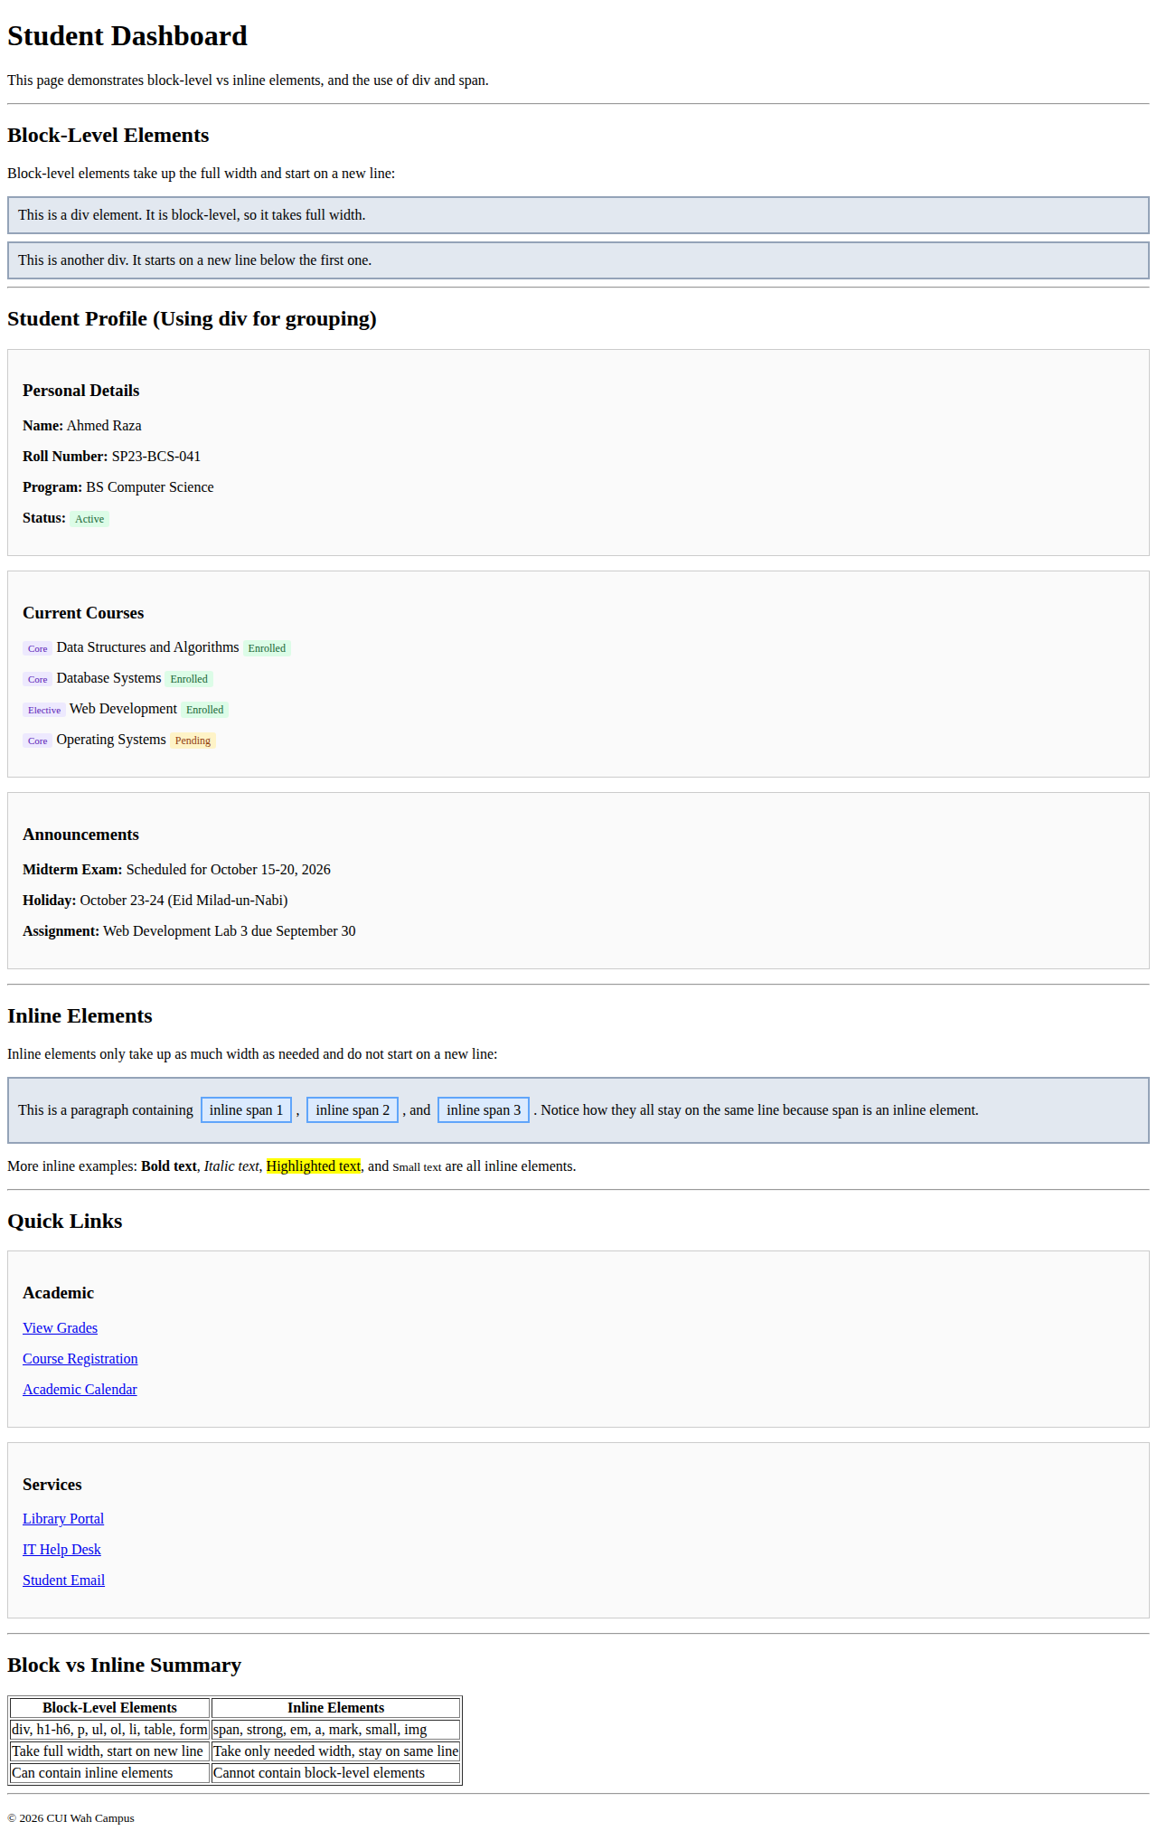
Output: index.html (Lab 07)

Lab 08: Semantic HTML5 Page Structure

File: index.html
<!DOCTYPE html>
<html lang="en">
<head>
<!-- Lab 08: Semantic HTML5 Page Structure -->
<meta charset="UTF-8">
<meta name="viewport" content="width=device-width, initial-scale=1.0">
<title>CUI Wah Campus - Semantic Structure</title>
<style>
/* Simple CSS to visualize semantic elements */
body { font-family: Arial, sans-serif; margin: 0; padding: 0; line-height: 1.6; }
header { background: #1a2332; color: white; padding: 16px 24px; }
nav { background: #2d3f54; padding: 12px 24px; }
nav a { color: #ccc; text-decoration: none; margin-right: 16px; }
nav a:hover { color: white; }
main { max-width: 900px; margin: 0 auto; padding: 24px; }
section { margin-bottom: 30px; padding: 20px; border: 1px solid #e2e8f0; border-radius: 8px; background: #f9fafb; }
article { background: white; padding: 16px; border: 1px solid #e5e7eb; border-radius: 6px; margin-bottom: 16px; }
aside { background: #eff6ff; padding: 16px; border-left: 4px solid #3b82f6; margin: 16px 0; }
footer { background: #1a2332; color: #9ca3af; text-align: center; padding: 16px; font-size: 13px; }
h1 { margin: 0; font-size: 20px; }
h2 { color: #1a2332; border-bottom: 2px solid #e5e7eb; padding-bottom: 8px; }
</style>
</head>
<body>

<!-- HEADER: Site identity and branding -->
<header>
<h1>CUI Wah Campus</h1>
<p>COMSATS University Islamabad - Wah Campus</p>
</header>

<!-- NAV: Navigation links -->
<nav>
<a href="#home">Home</a>
<a href="#about">About</a>
<a href="#news">News</a>
<a href="#programs">Programs</a>
<a href="#contact">Contact</a>
</nav>

<!-- MAIN: Primary content of the page -->
<main>

<!-- SECTION: Major topic - About -->
<section id="about">
<h2>About CUI Wah Campus</h2>
<p>
COMSATS University Islamabad, Wah Campus is one of the leading campuses
providing quality education in various disciplines. The campus offers
undergraduate and graduate programs in Computer Science, Software Engineering,
Management Sciences, and more.
</p>
</section>

<!-- SECTION: News with ARTICLE elements -->
<section id="news">
<h2>Latest News</h2>

<!-- ARTICLE: Independent content block -->
<article>
<h3>Midterm Examinations Schedule Announced</h3>
<p><small>Published: September 20, 2026</small></p>
<p>
The midterm examinations for Fall 2026 semester will be conducted from
October 15 to October 20, 2026. Students are advised to check their
individual schedules on the student portal.
</p>
</article>

<!-- ARTICLE: Another independent content block -->
<article>
<h3>Web Development Workshop</h3>
<p><small>Published: September 18, 2026</small></p>
<p>
A two-day workshop on modern web development technologies will be held
on October 5-6, 2026. The workshop will cover HTML5, CSS3, and JavaScript
fundamentals. Registration is open for all students.
</p>
</article>

<!-- ASIDE: Related information -->
<aside>
<h3>Related Links</h3>
<ul>
<li><a href="#">Academic Calendar 2026</a></li>
<li><a href="#">Examination Rules</a></li>
<li><a href="#">Student Portal Login</a></li>
</ul>
</aside>
</section>

<!-- SECTION: Programs -->
<section id="programs">
<h2>Our Programs</h2>

<article>
<h3>BS Computer Science</h3>
<p>
A 4-year undergraduate program covering computing fundamentals,
programming, algorithms, databases, and software engineering.
</p>
</article>

<article>
<h3>BS Software Engineering</h3>
<p>
A 4-year program focused on software development lifecycle,
testing, project management, and quality assurance.
</p>
</article>
</section>

<!-- ASIDE: Sidebar information -->
<aside>
<h3>Campus Hours</h3>
<p>Monday - Friday: 8:00 AM - 5:00 PM</p>
<p>Saturday: 9:00 AM - 1:00 PM</p>
<p>Sunday: Closed</p>
</aside>

</main>

<!-- FOOTER: Closing information -->
<footer>
<p>&copy; 2026 COMSATS University Islamabad, Wah Campus. All rights reserved.</p>
<p>Address: Park Road, Chak Shahzad, Islamabad 45550</p>
</footer>

</body>
</html>

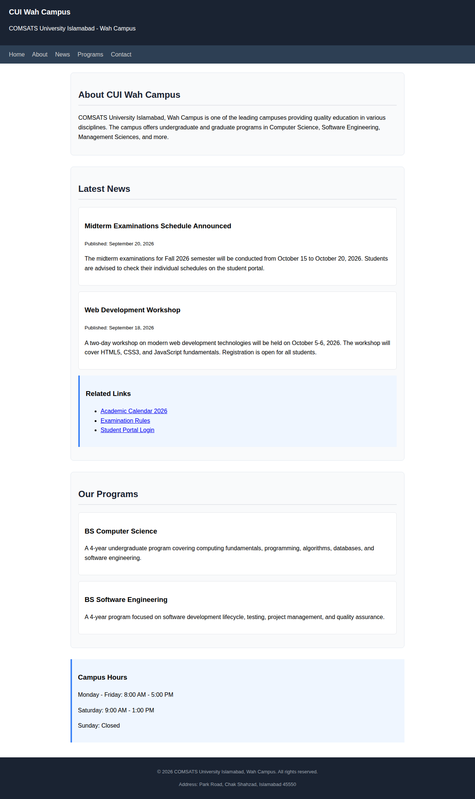
Output: index.html (Lab 08)

Lab 09: Accessibility and SEO with Semantic HTML

File: index.html
<!DOCTYPE html>
<html lang="en">
<head>
<!-- Lab 09: Accessibility and SEO with Semantic HTML -->
<meta charset="UTF-8">
<meta name="viewport" content="width=device-width, initial-scale=1.0">
<meta name="description" content="CUI Wah Campus - COMSATS University Islamabad Wah Campus official page with programs, facilities, and student information">
<meta name="keywords" content="COMSATS, CUI, Wah Campus, Computer Science, University, Education">
<meta name="author" content="CUI Wah Campus">
<title>CUI Wah Campus - Accessible & SEO Optimized</title>
<style>
body { font-family: Arial, sans-serif; margin: 0; padding: 0; line-height: 1.7; color: #111; }
/* Skip Link - for keyboard/screen reader users */
.skip-link { position: absolute; top: -40px; left: 0; background: #1a2332; color: white; padding: 8px 16px; z-index: 100; text-decoration: none; }
.skip-link:focus { top: 0; }
header { background: #1a2332; color: white; padding: 16px 24px; }
nav { background: #2d3f54; padding: 12px 24px; }
nav a { color: #ccc; text-decoration: none; margin-right: 16px; }
nav a:hover, nav a:focus { color: white; text-decoration: underline; }
main { max-width: 900px; margin: 0 auto; padding: 24px; }
section { margin-bottom: 30px; }
footer { background: #1a2332; color: #9ca3af; text-align: center; padding: 16px; font-size: 13px; }
a:focus, button:focus, input:focus { outline: 3px solid #3b82f6; outline-offset: 2px; }
img { max-width: 100%; height: auto; }
</style>
</head>
<body>

<!-- Skip Link: Allows keyboard users to skip to main content -->
<a href="#main-content" class="skip-link">Skip to main content</a>

<header role="banner">
<h1>CUI Wah Campus</h1>
<p>COMSATS University Islamabad - Wah Campus</p>
</header>

<nav role="navigation" aria-label="Main navigation">
<a href="#about">About</a>
<a href="#programs">Programs</a>
<a href="#facilities">Facilities</a>
<a href="#contact">Contact</a>
</nav>

<!-- MAIN: Primary content with landmark role -->
<main id="main-content" role="main">

<section id="about" aria-labelledby="about-heading">
<h2 id="about-heading">About CUI Wah Campus</h2>
<p>
COMSATS University Islamabad, Wah Campus provides quality education in
a modern learning environment. Our campus is equipped with state-of-the-art
facilities and experienced faculty members.
</p>
<img src="https://via.placeholder.com/400x200/1a2332/ffffff?text=CUI+Campus"
alt="COMSATS University Wah Campus main building with green lawns and modern architecture"
width="400" height="200">
</section>

<section id="programs" aria-labelledby="programs-heading">
<h2 id="programs-heading">Academic Programs</h2>

<article aria-labelledby="cs-heading">
<h3 id="cs-heading">BS Computer Science</h3>
<p>
A comprehensive 4-year program covering programming, algorithms,
data structures, databases, and software engineering.
</p>
</article>

<article aria-labelledby="se-heading">
<h3 id="se-heading">BS Software Engineering</h3>
<p>
A 4-year program focused on software development lifecycle,
quality assurance, and project management.
</p>
</article>
</section>

<section id="facilities" aria-labelledby="facilities-heading">
<h2 id="facilities-heading">Campus Facilities</h2>
<ul>
<li>Modern Computer Laboratories</li>
<li>University Library with digital resources</li>
<li>High-speed internet across campus</li>
<li>Cafeteria and food court</li>
<li>Sports complex and gymnasium</li>
</ul>
</section>

<section id="contact" aria-labelledby="contact-heading">
<h2 id="contact-heading">Contact Information</h2>
<address>
<p><strong>Address:</strong> COMSATS University Islamabad, Park Road, Chak Shahzad, Islamabad 45550</p>
<p><strong>Phone:</strong> <a href="tel:+92518157218">+92-51-8157218</a></p>
<p><strong>Email:</strong> <a href="mailto:info@comsats.edu.pk">info@comsats.edu.pk</a></p>
</address>
</section>

</main>

<footer role="contentinfo">
<p>&copy; 2026 COMSATS University Islamabad, Wah Campus. All rights reserved.</p>
</footer>

</body>
</html>

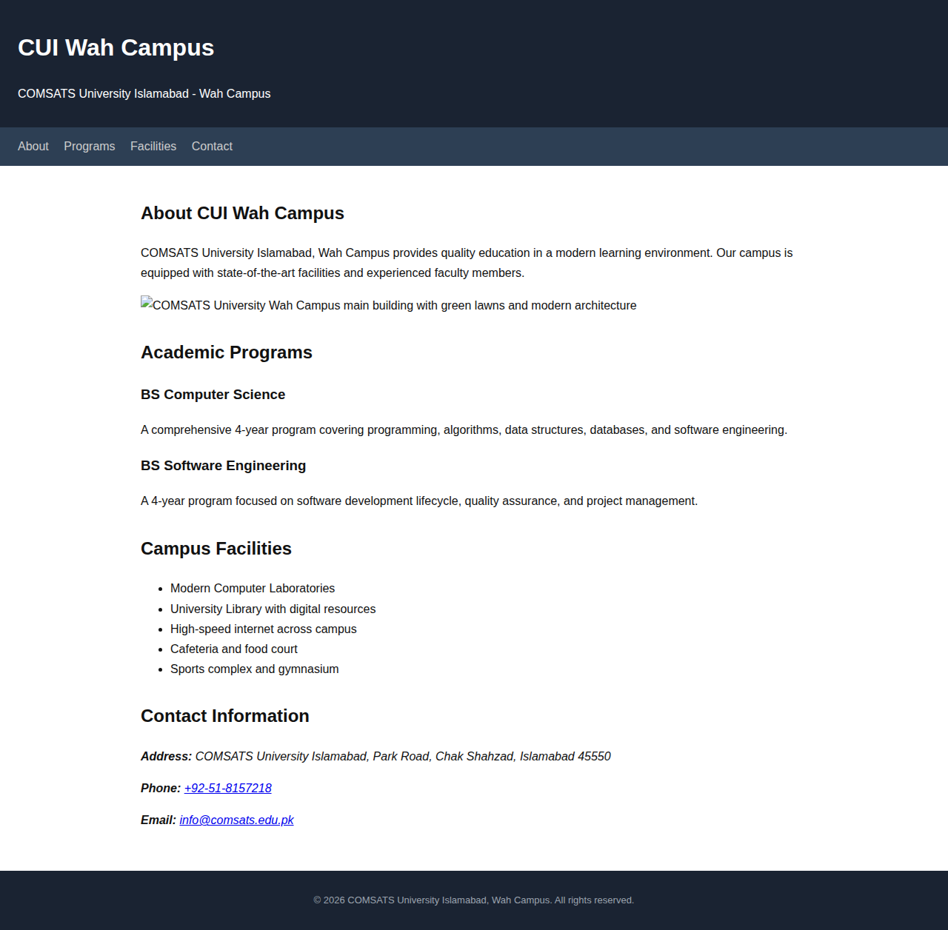
Output: index.html (Lab 09)

Lab 10: HTML Forms: action, method and Form Controls

File: index.html
<!DOCTYPE html>
<html lang="en">
<head>
<!-- Lab 10: HTML Forms - action, method and Form Controls -->
<meta charset="UTF-8">
<meta name="viewport" content="width=device-width, initial-scale=1.0">
<title>Workshop Registration - CUI Wah</title>
<style>
body { font-family: Arial, sans-serif; max-width: 700px; margin: 0 auto; padding: 24px; line-height: 1.6; }
h1 { color: #1a2332; }
fieldset { border: 2px solid #e5e7eb; border-radius: 8px; padding: 20px; margin-bottom: 20px; }
legend { font-weight: bold; padding: 0 8px; color: #1a2332; }
label { display: block; margin-bottom: 4px; font-weight: 500; font-size: 14px; }
input, select, textarea { width: 100%; padding: 8px 12px; border: 1px solid #ccc; border-radius: 4px; font-size: 14px; margin-bottom: 14px; }
.radio-group label, .checkbox-group label { display: inline; font-weight: normal; margin-right: 16px; }
.radio-group input, .checkbox-group input { width: auto; margin-right: 4px; }
button { padding: 10px 20px; border: none; border-radius: 4px; font-size: 14px; cursor: pointer; margin-right: 8px; }
.btn-submit { background: #2563eb; color: white; }
.btn-reset { background: #e5e7eb; color: #333; }
</style>
</head>
<body>

<h1>Workshop Registration Form</h1>
<p>Register for the upcoming Web Development Workshop at CUI Wah Campus.</p>

<!-- FORM with action and method -->
<!-- action = where the form data is sent -->
<!-- method = how the form data is sent (GET or POST) -->
<form action="https://example.com/submit-registration" method="POST">

<!-- Fieldset 1: Personal Information -->
<fieldset>
<legend>Personal Information</legend>

<label for="fullname">Full Name *</label>
<input type="text" id="fullname" name="fullname" placeholder="Enter your full name" required>

<label for="email">Email Address *</label>
<input type="email" id="email" name="email" placeholder="you@comsats.edu.pk" required>

<label for="password">Create Password *</label>
<input type="password" id="password" name="password" placeholder="Min 8 characters" required>

<label for="phone">Phone Number</label>
<input type="tel" id="phone" name="phone" placeholder="+92-3XX-XXXXXXX">

<label for="dob">Date of Birth</label>
<input type="date" id="dob" name="dob">

<label for="roll">Roll Number *</label>
<input type="text" id="roll" name="roll" placeholder="e.g., SP23-BCS-041" required>
</fieldset>

<!-- Fieldset 2: Workshop Details -->
<fieldset>
<legend>Workshop Details</legend>

<label for="program">Select Program *</label>
<select id="program" name="program" required>
<option value="">-- Choose your program --</option>
<option value="cs">BS Computer Science</option>
<option value="se">BS Software Engineering</option>
<option value="it">BS Information Technology</option>
<option value="other">Other</option>
</select>

<label for="semester">Current Semester</label>
<input type="number" id="semester" name="semester" min="1" max="8" placeholder="e.g., 5">

<label>Workshop Topics (select all that apply):</label>
<div class="checkbox-group">
<input type="checkbox" id="html" name="topic" value="html">
<label for="html">HTML5</label>

<input type="checkbox" id="css" name="topic" value="css">
<label for="css">CSS3</label>

<input type="checkbox" id="js" name="topic" value="javascript">
<label for="js">JavaScript</label>

<input type="checkbox" id="react" name="topic" value="react">
<label for="react">React</label>
</div>

<label>Preferred Session Time:</label>
<div class="radio-group">
<input type="radio" id="morning" name="session" value="morning">
<label for="morning">Morning (9-12)</label>

<input type="radio" id="afternoon" name="session" value="afternoon">
<label for="afternoon">Afternoon (2-5)</label>

<input type="radio" id="evening" name="session" value="evening">
<label for="evening">Evening (6-9)</label>
</div>
</fieldset>

<!-- Fieldset 3: Additional Information -->
<fieldset>
<legend>Additional Information</legend>

<label for="experience">Experience Level</label>
<input type="range" id="experience" name="experience" min="0" max="10" value="3">
<small>0 = No experience, 10 = Expert</small>

<label for="comments">Any special requirements or comments:</label>
<textarea id="comments" name="comments" rows="4" placeholder="Tell us if you need any accommodations..."></textarea>

<label for="document">Upload ID Card (optional)</label>
<input type="file" id="document" name="document" accept=".pdf,.jpg,.png">
</fieldset>

<!-- Buttons -->
<button type="submit" class="btn-submit">Register Now</button>
<button type="reset" class="btn-reset">Clear Form</button>

</form>

<hr>
<h3>About GET vs POST</h3>
<p><strong>GET:</strong> Sends form data in the URL. Good for search forms. Data is visible in the address bar.</p>
<p><strong>POST:</strong> Sends form data in the request body. Better for sensitive data like passwords. Data is not visible in the URL.</p>
<p>This form uses <strong>POST</strong> because it submits personal information.</p>

<p><small>&copy; 2026 CUI Wah Campus</small></p>

</body>
</html>

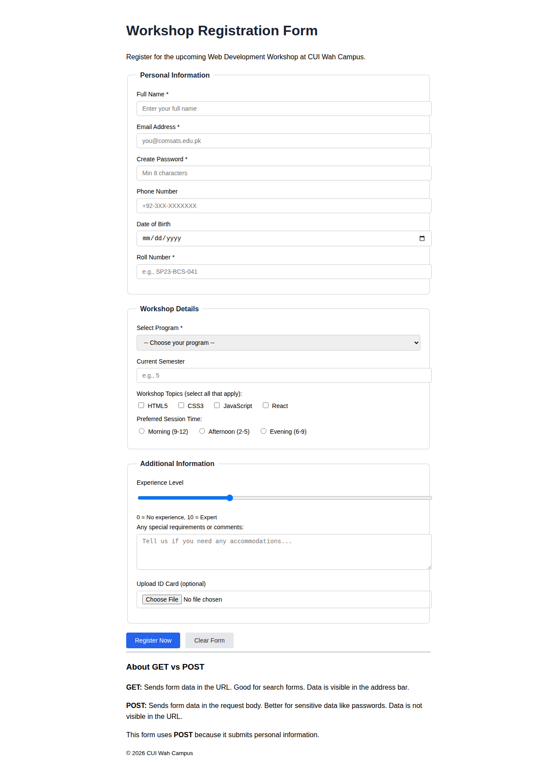
Output: index.html (Lab 10)

Lab 11: HTML5 Client-Side Form Validation

File: index.html
<!DOCTYPE html>
<html lang="en">
<head>
<!-- Lab 11: HTML5 Client-Side Form Validation -->
<meta charset="UTF-8">
<meta name="viewport" content="width=device-width, initial-scale=1.0">
<title>Registration Form with Validation - CUI Wah</title>
<style>
body { font-family: Arial, sans-serif; max-width: 700px; margin: 0 auto; padding: 24px; line-height: 1.6; }
h1 { color: #1a2332; }
fieldset { border: 2px solid #e5e7eb; border-radius: 8px; padding: 20px; margin-bottom: 20px; }
legend { font-weight: bold; padding: 0 8px; color: #1a2332; }
label { display: block; margin-bottom: 4px; font-weight: 500; font-size: 14px; }
input, select, textarea { width: 100%; padding: 8px 12px; border: 1px solid #ccc; border-radius: 4px; font-size: 14px; margin-bottom: 6px; }
small { color: #666; display: block; margin-bottom: 14px; }
.required-note { color: #dc2626; font-size: 13px; margin-bottom: 16px; }
button { padding: 10px 20px; border: none; border-radius: 4px; font-size: 14px; cursor: pointer; margin-right: 8px; background: #2563eb; color: white; }
.btn-reset { background: #e5e7eb; color: #333; }
.test-results { background: #f0fdf4; border: 1px solid #bbf7d0; padding: 16px; border-radius: 8px; margin-top: 20px; }
.test-results h3 { margin-top: 0; color: #166534; }
table { width: 100%; border-collapse: collapse; margin-top: 10px; }
th, td { border: 1px solid #ccc; padding: 8px; text-align: left; font-size: 13px; }
th { background: #f3f4f6; }
.pass { color: #16a34a; }
.fail { color: #dc2626; }
</style>
</head>
<body>

<h1>Workshop Registration Form</h1>
<p>With HTML5 client-side validation attributes.</p>
<p class="required-note">* Required fields are marked with an asterisk.</p>

<form action="https://example.com/register" method="POST" novalidate>

<fieldset>
<legend>Personal Information</legend>

<!-- REQUIRED: field cannot be empty -->
<label for="fullname">Full Name *</label>
<input type="text" id="fullname" name="fullname" required minlength="3" maxlength="50" placeholder="Enter your full name">
<small>Min 3 characters, Max 50 characters</small>

<!-- REQUIRED + EMAIL type validation -->
<label for="email">Email Address *</label>
<input type="email" id="email" name="email" required placeholder="you@comsats.edu.pk">
<small>Must be a valid email format (e.g., user@domain.com)</small>

<!-- REQUIRED + PATTERN for phone format -->
<label for="phone">Phone Number *</label>
<input type="tel" id="phone" name="phone" required pattern="03[0-9]{9}" placeholder="03XXXXXXXXX" maxlength="11">
<small>Must start with 03 followed by 9 digits (e.g., 03001234567)</small>

<!-- REQUIRED + PATTERN for roll number -->
<label for="roll">Roll Number *</label>
<input type="text" id="roll" name="roll" required pattern="[A-Z]{2}[0-9]{2}-[A-Z]{3}-[0-9]{3}" placeholder="SP23-BCS-041">
<small>Format: XX##-XXX-### (e.g., SP23-BCS-041)</small>
</fieldset>

<fieldset>
<legend>Program Details</legend>

<!-- REQUIRED select -->
<label for="program">Select Program *</label>
<select id="program" name="program" required>
<option value="">-- Choose your program --</option>
<option value="cs">BS Computer Science</option>
<option value="se">BS Software Engineering</option>
<option value="it">BS Information Technology</option>
</select>

<!-- NUMBER with min/max -->
<label for="semester">Current Semester *</label>
<input type="number" id="semester" name="semester" required min="1" max="8" value="1">
<small>Must be between 1 and 8</small>

<!-- DATE with min/max -->
<label for="regdate">Registration Date *</label>
<input type="date" id="regdate" name="regdate" required min="2026-09-01" max="2026-12-31">
<small>Must be between Sept 1, 2026 and Dec 31, 2026</small>
</fieldset>

<fieldset>
<legend>Additional Details</label>

<!-- TEXTAREA with minlength/maxlength -->
<label for="experience">Tell us about your experience *</label>
<textarea id="experience" name="experience" required minlength="20" maxlength="200" rows="4" placeholder="Describe your programming experience..."></textarea>
<small>Min 20 characters, Max 200 characters</small>

<!-- NUMBER with step -->
<label for="hours">Weekly study hours</label>
<input type="number" id="hours" name="hours" min="1" max="40" step="1" value="10">
<small>Between 1 and 40 hours per week</small>
</fieldset>

<button type="submit">Register</button>
<button type="reset" class="btn-reset">Clear Form</button>

</form>

<!-- Test Results Documentation -->
<div class="test-results">
<h3>Validation Test Results</h3>
<p>Below are the results of testing different inputs:</p>

<table>
<thead>
<tr>
<th>Field</th>
<th>Test Case</th>
<th>Input</th>
<th>Result</th>
</tr>
</thead>
<tbody>
<tr>
<td>Full Name</td>
<td>Empty field</td>
<td>(empty)</td>
<td class="pass">PASS - Browser shows "Please fill out this field"</td>
</tr>
<tr>
<td>Full Name</td>
<td>Too short</td>
<td>Ab</td>
<td class="pass">PASS - Browser shows "Please lengthen this text to 3 characters"</td>
</tr>
<tr>
<td>Email</td>
<td>Invalid format</td>
<td>notanemail</td>
<td class="pass">PASS - Browser shows "Please include an '@' in the email"</td>
</tr>
<tr>
<td>Phone</td>
<td>Wrong pattern</td>
<td>12345</td>
<td class="pass">PASS - Browser shows "Please match the requested format"</td>
</tr>
<tr>
<td>Phone</td>
<td>Valid input</td>
<td>03001234567</td>
<td class="pass">PASS - Accepted</td>
</tr>
<tr>
<td>Roll No</td>
<td>Wrong format</td>
<td>abc</td>
<td class="pass">PASS - Browser shows pattern mismatch</td>
</tr>
<tr>
<td>Semester</td>
<td>Out of range</td>
<td>10</td>
<td class="pass">PASS - Browser shows "Value must be less than or equal to 8"</td>
</tr>
<tr>
<td>Experience</td>
<td>Too short</td>
<td>Hello</td>
<td class="pass">PASS - Browser shows "Please lengthen this text to 20 characters"</td>
</tr>
</tbody>
</table>
</div>

<hr>
<h3>Important Note</h3>
<p><strong>Client-side validation is NOT a security control!</strong></p>
<p>It can be easily bypassed by disabling JavaScript or using developer tools. Always validate data on the server side as well.</p>

<p><small>&copy; 2026 CUI Wah Campus</small></p>

</body>
</html>

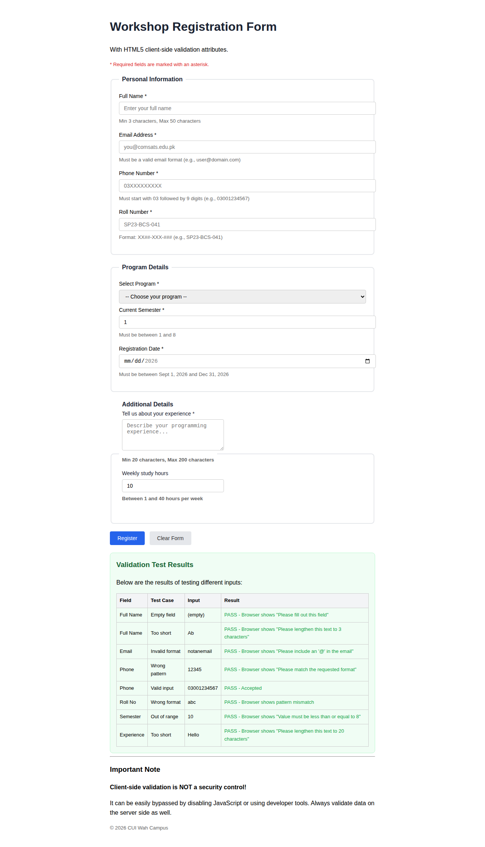
Output: index.html (Lab 11)

Lab 12: Integrated Project: CUI Wah Campus Web Portal

File: home.html
<!DOCTYPE html>
<html lang="en">
<head>
<!-- Lab 12: Integrated Project - CUI Wah Campus Web Portal -->
<!-- Page: Home -->
<meta charset="UTF-8">
<meta name="viewport" content="width=device-width, initial-scale=1.0">
<meta name="description" content="COMSATS University Islamabad Wah Campus - Official Website">
<title>CUI Wah Campus - Home</title>
<style>
* { margin: 0; padding: 0; box-sizing: border-box; }
body { font-family: Arial, sans-serif; line-height: 1.6; color: #111; }
header { background: #1a2332; color: white; padding: 16px 24px; }
header h1 { font-size: 20px; }
nav { background: #2d3f54; padding: 10px 24px; }
nav a { color: #ccc; text-decoration: none; margin-right: 16px; font-size: 14px; }
nav a:hover { color: white; text-decoration: underline; }
.hero { background: linear-gradient(135deg, #1a2332, #2d3f54); color: white; padding: 50px 24px; text-align: center; }
.hero h2 { font-size: 28px; margin-bottom: 10px; }
.hero p { font-size: 16px; color: #9ca3af; max-width: 500px; margin: 0 auto 20px; }
.hero a { display: inline-block; background: #3b82f6; color: white; padding: 10px 24px; border-radius: 6px; text-decoration: none; margin: 4px; }
.hero a:hover { background: #2563eb; }
main { max-width: 960px; margin: 0 auto; padding: 30px 24px; }
.cards { display: grid; grid-template-columns: repeat(3, 1fr); gap: 16px; margin: 20px 0; }
.card { border: 1px solid #e5e7eb; border-radius: 8px; padding: 20px; background: #f9fafb; }
.card h3 { color: #1a2332; margin-bottom: 8px; }
.card p { font-size: 14px; color: #6b7280; }
section { margin-bottom: 30px; }
footer { background: #1a2332; color: #9ca3af; text-align: center; padding: 16px; font-size: 13px; }
.skip-link { position: absolute; top: -40px; left: 0; background: #3b82f6; color: white; padding: 8px 16px; z-index: 100; text-decoration: none; }
.skip-link:focus { top: 0; }
</style>
</head>
<body>

<a href="#main-content" class="skip-link">Skip to main content</a>

<header role="banner">
<h1>CUI Wah Campus</h1>
</header>

<nav role="navigation" aria-label="Main navigation">
<a href="home.html"><strong>Home</strong></a>
<a href="programs.html">Programs</a>
<a href="facilities.html">Facilities & News</a>
<a href="admission.html">Admission & Contact</a>
</nav>

<section class="hero">
<h2>Welcome to CUI Wah Campus</h2>
<p>COMSATS University Islamabad - Providing quality education since 2002</p>
<a href="admission.html">Apply Now</a>
<a href="programs.html">View Programs</a>
</section>

<main id="main-content" role="main">

<section>
<h2>About CUI Wah Campus</h2>
<p>
COMSATS University Islamabad, Wah Campus is a leading institution offering
undergraduate and graduate programs in Computer Science, Software Engineering,
and Management Sciences. Our campus provides a modern learning environment with
experienced faculty and state-of-the-art facilities.
</p>
</section>

<section>
<h2>Quick Links</h2>
<div class="cards">
<div class="card">
<h3>Academic Programs</h3>
<p>Explore our BS and MS programs in CS, SE, IT, and Management.</p>
<p><a href="programs.html">View Programs &rarr;</a></p>
</div>
<div class="card">
<h3>Campus Facilities</h3>
<p>Modern labs, library, sports complex, and cafeteria.</p>
<p><a href="facilities.html">View Facilities &rarr;</a></p>
</div>
<div class="card">
<h3>Admissions</h3>
<p>Apply for Fall 2026 semester. Last date: October 15, 2026.</p>
<p><a href="admission.html">Apply Now &rarr;</a></p>
</div>
</div>
</section>

<section>
<h2>Contact</h2>
<address>
<p>COMSATS University Islamabad, Park Road, Chak Shahzad, Islamabad 45550</p>
<p>Phone: +92-51-8157218 | Email: <a href="mailto:info@comsats.edu.pk">info@comsats.edu.pk</a></p>
</address>
</section>

</main>

<footer role="contentinfo">
<p>&copy; 2026 COMSATS University Islamabad, Wah Campus. All rights reserved.</p>
</footer>

</body>
</html>

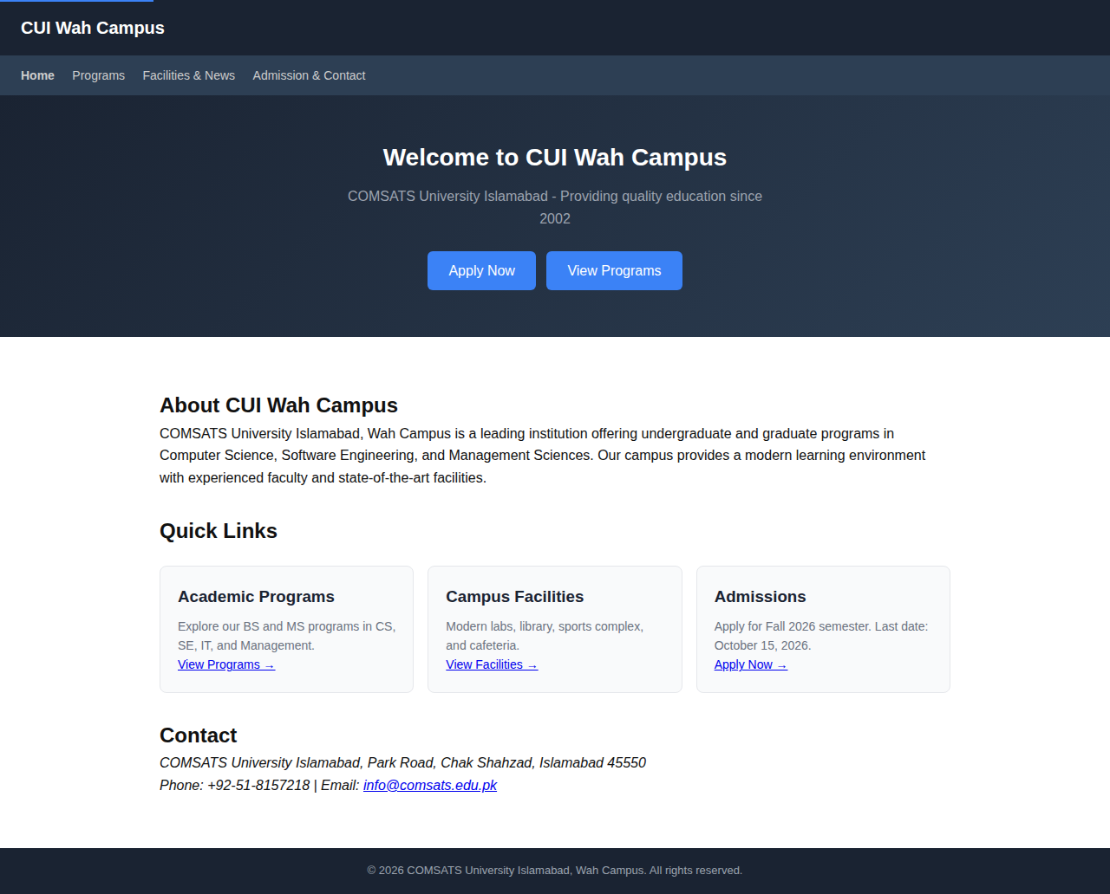
Output: home.html (Lab 12)

File: admission.html
<!DOCTYPE html>
<html lang="en">
<head>
<!-- Lab 12: Integrated Project - Admission & Contact Page -->
<meta charset="UTF-8">
<meta name="viewport" content="width=device-width, initial-scale=1.0">
<meta name="description" content="Admission information and contact details for CUI Wah Campus">
<title>Admission & Contact - CUI Wah Campus</title>
<style>
* { margin: 0; padding: 0; box-sizing: border-box; }
body { font-family: Arial, sans-serif; line-height: 1.6; color: #111; }
header { background: #1a2332; color: white; padding: 16px 24px; }
header h1 { font-size: 20px; }
nav { background: #2d3f54; padding: 10px 24px; }
nav a { color: #ccc; text-decoration: none; margin-right: 16px; font-size: 14px; }
nav a:hover { color: white; text-decoration: underline; }
main { max-width: 960px; margin: 0 auto; padding: 30px 24px; }
section { margin-bottom: 30px; }
fieldset { border: 2px solid #e5e7eb; border-radius: 8px; padding: 20px; margin-bottom: 20px; }
legend { font-weight: bold; padding: 0 8px; color: #1a2332; }
label { display: block; margin-bottom: 4px; font-weight: 500; font-size: 14px; }
input, select, textarea { width: 100%; padding: 8px 12px; border: 1px solid #ccc; border-radius: 4px; font-size: 14px; margin-bottom: 6px; }
small { color: #666; display: block; margin-bottom: 14px; }
button { padding: 10px 20px; border: none; border-radius: 4px; font-size: 14px; cursor: pointer; background: #2563eb; color: white; margin-right: 8px; }
.btn-reset { background: #e5e7eb; color: #333; }
table { width: 100%; border-collapse: collapse; margin: 16px 0; }
th, td { border: 1px solid #ccc; padding: 10px; text-align: left; font-size: 14px; }
th { background: #f3f4f6; }
aside { background: #eff6ff; border-left: 4px solid #3b82f6; padding: 16px; margin: 16px 0; }
footer { background: #1a2332; color: #9ca3af; text-align: center; padding: 16px; font-size: 13px; }
</style>
</head>
<body>

<header role="banner">
<h1>CUI Wah Campus</h1>
</header>

<nav role="navigation" aria-label="Main navigation">
<a href="home.html">Home</a>
<a href="programs.html">Programs</a>
<a href="facilities.html">Facilities & News</a>
<a href="admission.html"><strong>Admission & Contact</strong></a>
</nav>

<main role="main">

<!-- Admission Section -->
<section id="admission">
<h2>Admission Information</h2>

<h3>How to Apply</h3>
<ol>
<li>Visit the COMSATS admissions portal</li>
<li>Create an account with your personal details</li>
<li>Fill out the application form completely</li>
<li>Upload required documents (CNIC, transcripts, photos)</li>
<li>Pay the application fee via bank challan</li>
<li>Submit before the deadline</li>
</ol>

<h3>Important Dates - Fall 2026</h3>
<table>
<thead>
<tr>
<th>Event</th>
<th>Date</th>
</tr>
</thead>
<tbody>
<tr><td>Admissions Open</td><td>August 1, 2026</td></tr>
<tr><td>Application Deadline</td><td>October 15, 2026</td></tr>
<tr><td>Merit List Announcement</td><td>October 25, 2026</td></tr>
<tr><td>Fee Submission Deadline</td><td>November 5, 2026</td></tr>
<tr><td>Classes Begin</td><td>November 10, 2026</td></tr>
</tbody>
</table>

<!-- FAQ using details/summary -->
<h3>Frequently Asked Questions</h3>

<details>
<summary>What is the admission criteria?</summary>
<p>For BS programs, candidates must have Intermediate (or equivalent) with minimum 50% marks. Admission is based on merit calculated from academic records and entry test.</p>
</details>

<details>
<summary>Is there a scholarship available?</summary>
<p>Yes, CUI offers merit-based and need-based scholarships. Top performers can get up to 100% tuition waiver.</p>
</details>

<details>
<summary>Can I transfer from another university?</summary>
<p>Transfer admissions are available for students with good academic standing. Credit transfer is subject to departmental approval.</p>
</details>

<details>
<summary>What documents are required?</summary>
<p>CNIC/B-Form, Matric certificates, Intermediate transcripts, Equivalence certificate (if applicable), Character certificate, and passport-size photographs.</p>
</details>
</section>

<!-- Contact Form -->
<section id="contact">
<h2>Contact Us</h2>

<form action="https://example.com/contact-submit" method="POST">

<fieldset>
<legend>Send us a Message</legend>

<label for="name">Your Name *</label>
<input type="text" id="name" name="name" required minlength="3" placeholder="Enter your name">

<label for="email">Email Address *</label>
<input type="email" id="email" name="email" required placeholder="you@example.com">

<label for="subject">Subject *</label>
<select id="subject" name="subject" required>
<option value="">-- Select Subject --</option>
<option value="admission">Admission Inquiry</option>
<option value="programs">Program Information</option>
<option value="fee">Fee Structure</option>
<option value="other">Other</option>
</select>

<label for="message">Message *</label>
<textarea id="message" name="message" rows="5" required minlength="10" placeholder="Write your message here..."></textarea>
<small>Minimum 10 characters</small>

<button type="submit">Send Message</button>
<button type="reset" class="btn-reset">Clear</button>
</fieldset>

</form>
</section>

<!-- Contact Information -->
<section>
<h2>Contact Information</h2>
<address>
<p><strong>Address:</strong> COMSATS University Islamabad, Park Road, Chak Shahzad, Islamabad 45550, Pakistan</p>
<p><strong>Phone:</strong> <a href="tel:+92518157218">+92-51-8157218</a></p>
<p><strong>Email:</strong> <a href="mailto:info@comsats.edu.pk">info@comsats.edu.pk</a></p>
<p><strong>Office Hours:</strong> Monday - Friday: 8:00 AM - 5:00 PM</p>
</address>
</section>

<aside>
<h3>Quick Links</h3>
<ul>
<li><a href="home.html">Home</a></li>
<li><a href="programs.html">Programs</a></li>
<li><a href="facilities.html">Facilities</a></li>
<li><a href="https://www.comsats.edu.pk" target="_blank" rel="noopener noreferrer">COMSATS Official Website</a></li>
</ul>
</aside>

</main>

<footer role="contentinfo">
<p>&copy; 2026 COMSATS University Islamabad, Wah Campus. All rights reserved.</p>
</footer>

</body>
</html>

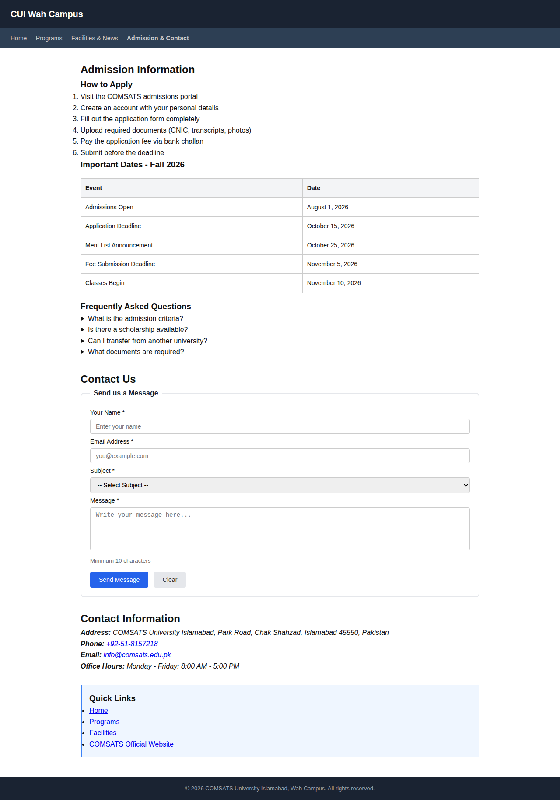
Output: admission.html (Lab 12)

File: programs.html
<!DOCTYPE html>
<html lang="en">
<head>
<!-- Lab 12: Integrated Project - Programs/Academics Page -->
<meta charset="UTF-8">
<meta name="viewport" content="width=device-width, initial-scale=1.0">
<meta name="description" content="Academic programs offered at CUI Wah Campus">
<title>Programs - CUI Wah Campus</title>
<style>
* { margin: 0; padding: 0; box-sizing: border-box; }
body { font-family: Arial, sans-serif; line-height: 1.6; color: #111; }
header { background: #1a2332; color: white; padding: 16px 24px; }
header h1 { font-size: 20px; }
nav { background: #2d3f54; padding: 10px 24px; }
nav a { color: #ccc; text-decoration: none; margin-right: 16px; font-size: 14px; }
nav a:hover { color: white; text-decoration: underline; }
main { max-width: 960px; margin: 0 auto; padding: 30px 24px; }
table { width: 100%; border-collapse: collapse; margin: 16px 0; }
th, td { border: 1px solid #ccc; padding: 10px; text-align: left; font-size: 14px; }
th { background: #1a2332; color: white; }
caption { font-weight: bold; font-size: 16px; margin-bottom: 8px; text-align: left; }
section { margin-bottom: 30px; }
footer { background: #1a2332; color: #9ca3af; text-align: center; padding: 16px; font-size: 13px; }
</style>
</head>
<body>

<header role="banner">
<h1>CUI Wah Campus</h1>
</header>

<nav role="navigation" aria-label="Main navigation">
<a href="home.html">Home</a>
<a href="programs.html"><strong>Programs</strong></a>
<a href="facilities.html">Facilities & News</a>
<a href="admission.html">Admission & Contact</a>
</nav>

<main role="main">

<section>
<h2>Academic Programs</h2>
<p>CUI Wah Campus offers the following undergraduate and graduate programs.</p>
</section>

<section>
<h3>Undergraduate Programs</h3>
<table>
<caption>BS Programs - Fall 2026</caption>
<thead>
<tr>
<th scope="col">Program</th>
<th scope="col">Duration</th>
<th scope="col">Credit Hours</th>
<th scope="col">Eligibility</th>
</tr>
</thead>
<tbody>
<tr>
<td>BS Computer Science</td>
<td>4 Years</td>
<td>130</td>
<td>Intermediate with Mathematics</td>
</tr>
<tr>
<td>BS Software Engineering</td>
<td>4 Years</td>
<td>136</td>
<td>Intermediate with Mathematics</td>
</tr>
<tr>
<td>BS Information Technology</td>
<td>4 Years</td>
<td>130</td>
<td>Intermediate with Mathematics</td>
</tr>
<tr>
<td>BS Management Sciences</td>
<td>4 Years</td>
<td>130</td>
<td>Intermediate (any group)</td>
</tr>
</tbody>
</table>
</section>

<section>
<h3>Graduate Programs</h3>
<table>
<caption>MS Programs</caption>
<thead>
<tr>
<th scope="col">Program</th>
<th scope="col">Duration</th>
<th scope="col">Credit Hours</th>
<th scope="col">Eligibility</th>
</tr>
</thead>
<tbody>
<tr>
<td>MS Computer Science</td>
<td>2 Years</td>
<td>30</td>
<td>BS in CS or related field</td>
</tr>
<tr>
<td>MS Software Engineering</td>
<td>2 Years</td>
<td>30</td>
<td>BS in SE/CS or related field</td>
</tr>
</tbody>
</table>
</section>

<section>
<h3>Semester-wise Course Plan (BS CS - 5th Semester)</h3>
<table>
<thead>
<tr>
<th>Course Code</th>
<th>Course Title</th>
<th>Credit Hours</th>
</tr>
</thead>
<tbody>
<tr><td>CS-301</td><td>Data Structures and Algorithms</td><td>3</td></tr>
<tr><td>CS-302</td><td>Database Systems</td><td>3</td></tr>
<tr><td>CS-303</td><td>Operating Systems</td><td>3</td></tr>
<tr><td>CS-304</td><td>Web Development</td><td>3</td></tr>
<tr><td>CS-305</td><td>OOP</td><td>3</td></tr>
<tr><td>CS-306</td><td>Discrete Mathematics</td><td>3</td></tr>
</tbody>
</table>
</section>

</main>

<footer role="contentinfo">
<p>&copy; 2026 COMSATS University Islamabad, Wah Campus. All rights reserved.</p>
</footer>

</body>
</html>

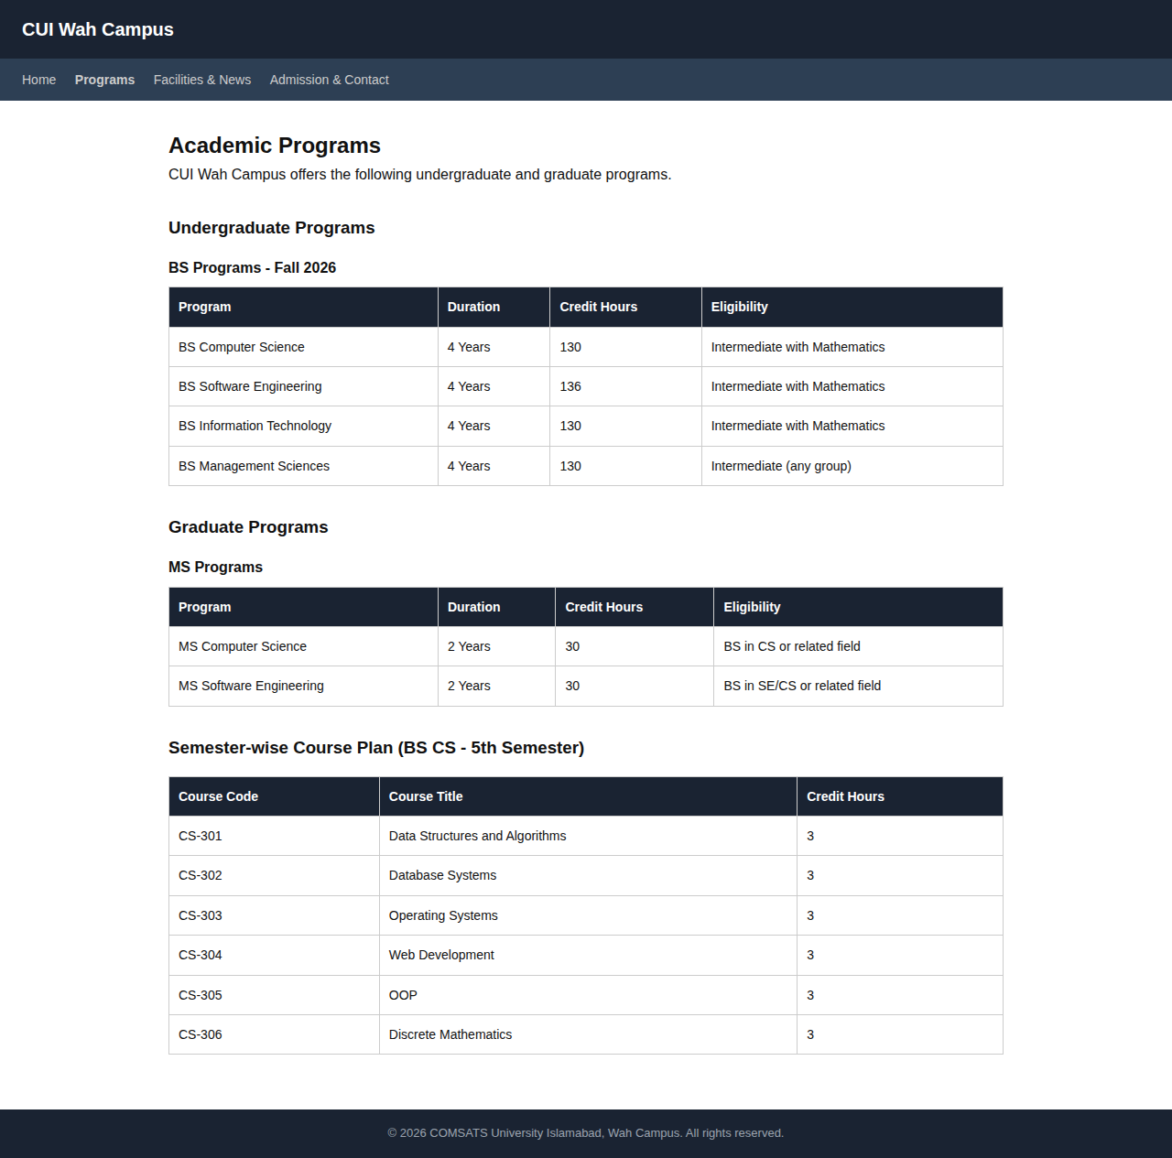
Output: programs.html (Lab 12)

File: facilities.html
<!DOCTYPE html>
<html lang="en">
<head>
<!-- Lab 12: Integrated Project - Facilities & News Page -->
<meta charset="UTF-8">
<meta name="viewport" content="width=device-width, initial-scale=1.0">
<meta name="description" content="Campus facilities and latest news at CUI Wah Campus">
<title>Facilities & News - CUI Wah Campus</title>
<style>
* { margin: 0; padding: 0; box-sizing: border-box; }
body { font-family: Arial, sans-serif; line-height: 1.6; color: #111; }
header { background: #1a2332; color: white; padding: 16px 24px; }
header h1 { font-size: 20px; }
nav { background: #2d3f54; padding: 10px 24px; }
nav a { color: #ccc; text-decoration: none; margin-right: 16px; font-size: 14px; }
nav a:hover { color: white; text-decoration: underline; }
main { max-width: 960px; margin: 0 auto; padding: 30px 24px; }
section { margin-bottom: 30px; }
article { border: 1px solid #e5e7eb; border-radius: 8px; padding: 20px; margin-bottom: 16px; background: #f9fafb; }
article h3 { color: #1a2332; margin-bottom: 6px; }
aside { background: #eff6ff; border-left: 4px solid #3b82f6; padding: 16px; margin: 16px 0; }
ul { padding-left: 20px; }
li { margin-bottom: 6px; }
figure { margin: 16px 0; }
figcaption { font-size: 13px; color: #6b7280; margin-top: 6px; }
footer { background: #1a2332; color: #9ca3af; text-align: center; padding: 16px; font-size: 13px; }
</style>
</head>
<body>

<header role="banner">
<h1>CUI Wah Campus</h1>
</header>

<nav role="navigation" aria-label="Main navigation">
<a href="home.html">Home</a>
<a href="programs.html">Programs</a>
<a href="facilities.html"><strong>Facilities & News</strong></a>
<a href="admission.html">Admission & Contact</a>
</nav>

<main role="main">

<!-- Facilities Section -->
<section id="facilities">
<h2>Campus Facilities</h2>

<figure>
<img src="https://via.placeholder.com/700x300/1a2332/ffffff?text=CUI+Campus+View"
alt="Panoramic view of COMSATS Wah Campus showing academic buildings and green areas"
width="700" height="300">
<figcaption>CUI Wah Campus - A view of the academic block and surrounding green areas</figcaption>
</figure>

<ul>
<li><strong>Computer Laboratories</strong> - 5 fully equipped labs with latest hardware and software</li>
<li><strong>University Library</strong> - Over 50,000 books and digital resources</li>
<li><strong>High-Speed Internet</strong> - Campus-wide Wi-Fi connectivity</li>
<li><strong>Cafeteria</strong> - Affordable meals and snacks</li>
<li><strong>Sports Complex</strong> - Cricket ground, basketball court, gymnasium</li>
<li><strong>Smart Classrooms</strong> - Projectors and interactive boards</li>
</ul>
</section>

<!-- News Section -->
<section id="news">
<h2>Latest News & Announcements</h2>

<article>
<h3>Midterm Examinations Schedule</h3>
<p><small>Published: September 20, 2026</small></p>
<p>
Midterm examinations for Fall 2026 will be held from October 15 to October 20, 2026.
Students are advised to check their schedules on the student portal.
</p>
</article>

<article>
<h3>Web Development Workshop</h3>
<p><small>Published: September 18, 2026</small></p>
<p>
A two-day workshop on HTML5, CSS3, and JavaScript will be conducted on October 5-6.
Register at the CS Department office.
</p>
</article>

<article>
<h3>Career Fair 2026</h3>
<p><small>Published: September 15, 2026</small></p>
<p>
Annual career fair will be held on October 25, 2026. Top tech companies
including Systems Limited, Netsol, and Techaxis will participate.
</p>
</article>

<aside>
<h3>Related Links</h3>
<ul>
<li><a href="#">Academic Calendar 2026</a></li>
<li><a href="#">Student Portal</a></li>
<li><a href="#">Examination Rules</a></li>
</ul>
</aside>
</section>

</main>

<footer role="contentinfo">
<p>&copy; 2026 COMSATS University Islamabad, Wah Campus. All rights reserved.</p>
</footer>

</body>
</html>

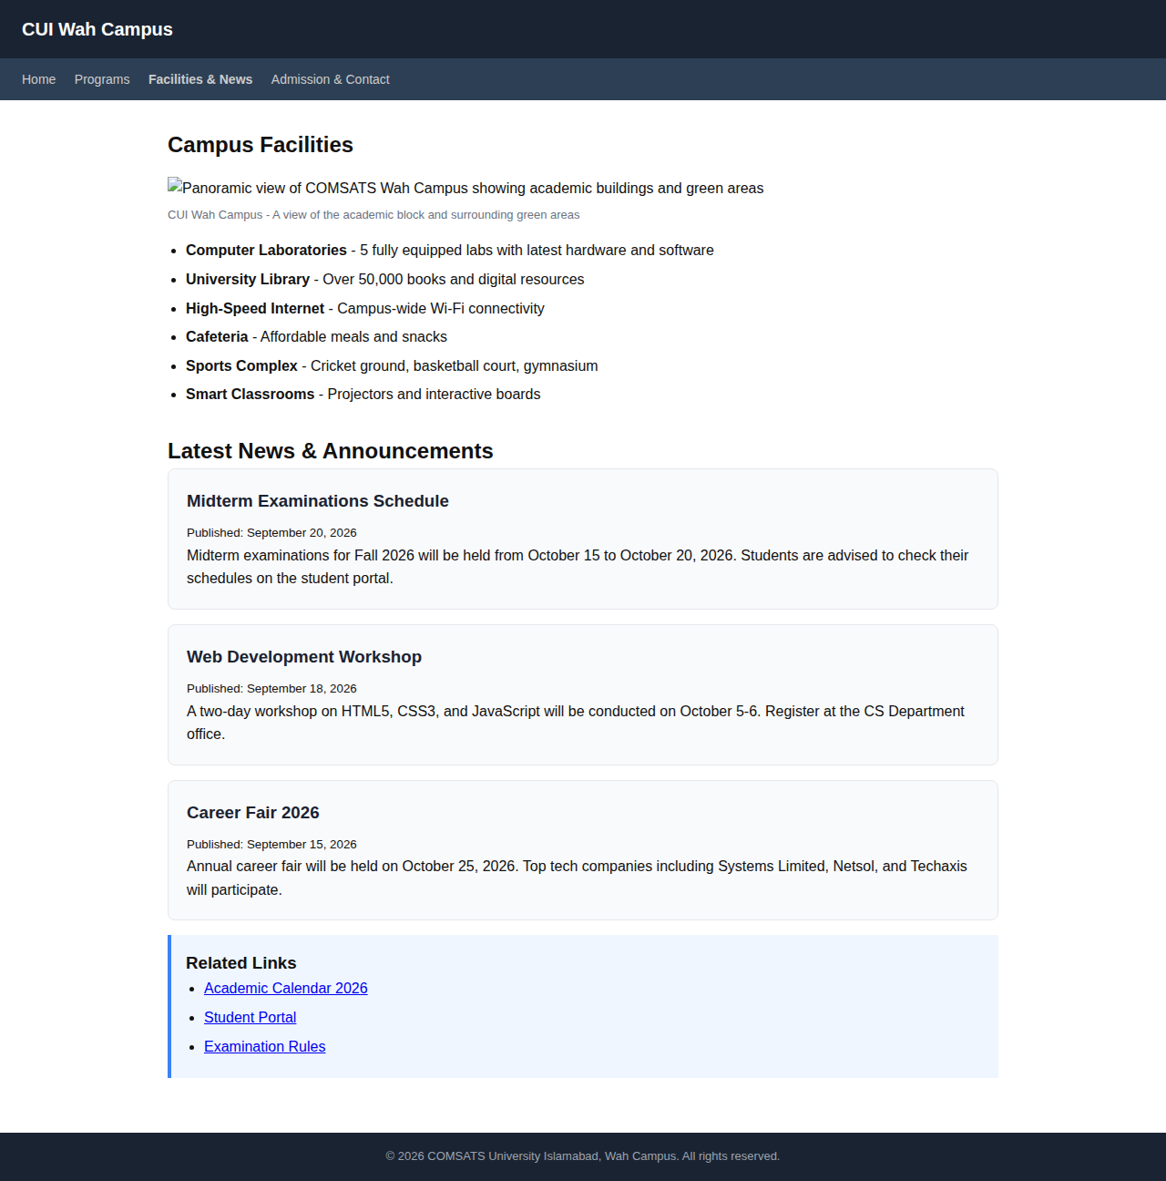
Output: facilities.html (Lab 12)

